UNITED STATES
SECURITIES AND EXCHANGE COMMISSION
Washington, D.C. 20549

FORM 8-K

CURRENT REPORT
PURSUANT TO SECTION 13 OR 15(d)
OF THE SECURITIES EXCHANGE ACT OF 1934
Date of Report (Date of earliest event reported): March 31, 2025

OPEN LENDING CORPORATION
(Exact name of registrant as specified in its charter)
Delaware |  |  | 001-39326 |  |  | 84-5031428
(State or other jurisdiction  of incorporation) |  |  | (Commission  File Number) |  |  | (IRS Employer  Identification No.)
1501 S. MoPac Expressway
Suite 450
Austin, Texas 78746
(Address of principal executive offices, including zip code)
Registrant’s telephone number, including area code: 512-892-0400
(Former name or former address, if changed since last report)
Check the appropriate box below if the Form 8-K filing is intended to simultaneously satisfy the filing obligation of the registrant under any of the following provisions:
☐ Written communications pursuant to Rule 425 under the Securities Act (17 CFR 230.425)
☐ Soliciting material pursuant to Rule 14a-12 under the Exchange Act (17 CFR 240.14a-12)
☐ Pre-commencement communications pursuant to Rule 14d-2(b) under the Exchange Act (17 CFR 240.14d-2(b))
☐ Pre-commencement communications pursuant to Rule 13e-4(c) under the Exchange Act (17 CFR 240.13e-4(c))

Securities registered pursuant to Section 12(b) of the Act:

Title of each class |  |  |  |  |  | Trading  Symbol(s) |  |  |  |  |  | Name of each exchange  on which registered
Common stock, par value $0.01 per share |  |  |  |  |  | LPRO |  |  |  |  |  | The Nasdaq Stock Market LLC
Indicate by check mark whether the registrant is an emerging growth company as defined in Rule 405 of the Securities Act of 1933 (§230.405 of this chapter) or Rule 12b-2 of the Securities Exchange Act of 1934 (§240.12b-2 of this chapter). Emerging growth company ☐
If an emerging growth company, indicate by check mark if the registrant has elected not to use the extended transition period for complying with any new or revised financial accounting standards provided pursuant to Section 13(a) of the Exchange Act. ☐

Item 2.02 Results of Operations and Financial Condition.
On March 31, 2025, Open Lending Corporation (the “Company”) issued a press release announcing its financial results for the fiscal quarter and full year ended December 31, 2024. A copy of the press release and additional supplemental financial information are attached as Exhibits 99.1 and 99.2, respectively, to this Current Report on Form 8-K and are incorporated by reference herein.
The information furnished under this Item 2.02 and in the accompanying Exhibits 99.1 and 99.2 shall not be deemed “filed” for purposes of Section 18 of the Securities Exchange Act of 1934, as amended (the “Exchange Act”), or incorporated by reference in any filing under the Securities Act of 1933, as amended, or the Exchange Act regardless of any general incorporation language in such filing, unless expressly incorporated by specific reference in such filing.

Item 9.01 Financial Statements and Exhibits.
(d) Exhibits
99.1 |  |  | Earnings Release, dated March 31, 2025
99.2 |  |  | Earnings Supplement Q4 2024
104 |  |  | Cover Page Interactive Data File (embedded within the Inline XBRL document)

1

SIGNATURES
Pursuant to the requirements of the Securities Exchange Act of 1934, the registrant has duly caused this report to be signed on its behalf by the undersigned hereunto duly authorized.

OPEN LENDING CORPORATION
By: |  |  |  |  |  | /s/ Matthew S. Stark
Name: |  |  |  |  |  | Matthew S. Stark
Title: |  |  |  |  |  | Chief Legal and Compliance Officer
Date: March 31, 2025

2
Exhibit 99.1

Open Lending Reports Fourth Quarter and Full Year 2024 Financial Results

AUSTIN, Texas, March 31, 2025 – Open Lending Corporation (Nasdaq: LPRO) (the “Company” or “Open Lending”), an industry trailblazer in lending enablement and risk analytics solutions for financial institutions, today reported financial results for its fourth quarter and full year ended December 31, 2024.
In a separate press release today, the Company announced that its Board of Directors (the “Board”) has appointed Jessica Buss, Chairman of the Board, as Chief Executive Officer, effective immediately. The Board has also appointed Michelle Glasl as Chief Operating Officer. Charles Jehl will continue to serve as Interim Chief Financial Officer and as a member of the Board.
Three Months Ended December 31, 2024 Highlights
•The Company facilitated 26,065 certified loans during the fourth quarter of 2024, compared to 26,263 certified loans in the fourth quarter of 2023.
•Total revenue was $(56.9) million during the fourth quarter of 2024, compared to $14.9 million in the fourth quarter of 2023. The fourth quarter of 2024 was negatively impacted by a $81.3 million reduction in estimated profit share revenues related to business in historic vintages as compared to a $14.3 million reduction in the fourth quarter of 2023.
•Gross loss was $63.2 million during the fourth quarter of 2024, compared to gross profit of $9.6 million in the fourth quarter of 2023.
•Net loss was $144.4 million during the fourth quarter of 2024, compared to a net loss of $4.8 million in the fourth quarter of 2023. The fourth quarter of 2024 was negatively impacted by the recording of a valuation allowance on our deferred tax assets of $86.1 million, which increased our income tax expense during the period.
•Adjusted EBITDA was $(73.1) million during the fourth quarter of 2024, compared to $(2.1) million in the fourth quarter of 2023.
Twelve Months Ended December 31, 2024 Highlights
•The Company facilitated 110,652 certified loans during the year ended December 31, 2024, compared to 122,984 certified loans in the prior year.
•Total revenue was $24.0 million during the year ended December 31, 2024, compared to $117.5 million in the prior year. The year ended December 31, 2024 was negatively impacted by a $96.1 million reduction in estimated profit share revenues related to business in historic vintages as compared to a $22.8 million reduction in the prior year.
•Gross profit was $0.2 million during the year ended December 31, 2024, compared to $95.2 million in the prior year.
•Net loss was $135.0 million during the year ended December 31, 2024, compared to net income of $22.1 million in the prior year.
•Adjusted EBITDA was $(42.9) million during the year ended December 31, 2024, compared to $50.2 million in the prior year.
Adjusted EBITDA is a non-GAAP financial measure. A reconciliation of this non-GAAP financial measure to its most directly comparable GAAP financial measure is provided in the financial table included at the end of this press release. An explanation of this measure and how it is calculated is also included under the heading “Non-GAAP Financial Measures.”
Fourth Quarter 2024 Impact Related to Profit Share Revenue Change in Estimates
Each quarter, the Company evaluates and updates its profit share revenue forecast and makes adjustments to its profit share revenue and related contract assets accordingly. Following this evaluation, for the fourth quarter of 2024, adjustments attributable to the Company's profit share revenue forecast resulted in a negative change in estimate of $81.3 million, primarily due to heightened delinquencies and corresponding defaults associated with loans originated in 2021 through 2024.

As discussed below, three factors primarily contributed to this reduction of estimated profit share.
First, there was continued deterioration of the Company's 2021 and 2022 vintages. These certified loans were generated when used car values reached an all-time high in late 2021, driven by pandemic-related disruptions in the supply chain. The subsequent decline in used car values has increased the likelihood of default on vehicles that are now worth significantly less than their corresponding outstanding loan balances. Adjustments to the forecasted performance of the Company's 2021 and 2022 vintages accounted for approximately 40% of the Company's total negative change in estimate for the fourth quarter of 2024.
Second, continued elevated delinquencies and ultimate defaults as a result of broader macroeconomic conditions accounted for approximately 20% of the Company's total negative change in estimate for the fourth quarter of 2024.
Finally, the Company identified two cohorts of borrowers, borrowers with credit builder tradelines and borrowers with fewer positive tradelines, that caused its 2023 and 2024 vintages to underperform. Adjustments to the forecasted performance of loans to these two cohorts of borrowers accounted for approximately 40% of the Company's total negative change in estimate for the fourth quarter of 2024.
As a result of the profit share change in estimate adjustment, for the fourth quarter of 2024, the Company reduced its contract assets by $33.7 million and recorded an excess profit share receipts liability of $47.6 million, attributable to the change in its expected profit share revenue. Any future adjustments to the Company's profit share revenue forecasts, positive or negative, will impact profit share revenue.
First Quarter 2025 Outlook
For the first quarter of 2025, the Company currently expects total certified loans to be between 27,000 and 28,000.

The guidance provided includes forward-looking statements within the meaning of U.S. securities laws. See “Forward-Looking Statements” below.
Board Changes
Jessica Buss will continue to serve as Chairman of the Board but will no longer be a member of the nominating and corporate governance and audit committees of the Board. Thomas Hegge will join the audit committee effective immediately.
Conference Call
Open Lending will host a conference call to discuss the fourth quarter and full year 2024 financial results tomorrow, April 1, 2025, at 8:00 am ET. The conference call will be webcast live from the Company's investor relations website at https://investors.openlending.com/ under the “Events” section. The conference call can also be accessed live over the phone by dialing (877) 407-4018, or for international callers (201) 689-8471; the conference ID is 13752724. An archive of the webcast will be available at the same location on the website shortly after the call has concluded.
About Open Lending
Open Lending (Nasdaq: LPRO) provides loan analytics, risk-based pricing, risk modeling and default insurance to auto lenders throughout the United States. For over 20 years, we have been empowering financial institutions to create profitable auto loan portfolios with less risk and more reward. For more information, please visit www.openlending.com.
Forward-Looking Statements
This press release includes certain statements that are not historical facts but are forward-looking statements for purposes of the safe harbor provisions under the United States Private Securities Litigation Reform Act of 1995, including statements related to market trends, consumer behavior and demand for automotive loans, as well as future financial performance under the heading "First Quarter 2025 Outlook" above. Forward-looking statements generally are accompanied by words such as “believe,” “may,” “will,” “estimate,” “continue,” “anticipate,” “intend,” “expect,” “should,” “would,” “plan,” “predict,” “potential,” “seem,” “seek,” “future,” “outlook,” and similar expressions that predict or indicate future events or trends or that are not statements of historical matters. These statements are based on various assumptions and on the current expectations of the Company’s management and are not predictions of actual performance. These forward-looking statements are provided for illustrative purposes only and are not intended to serve as, and must not be relied on by any investor as, a guarantee, an assurance, a prediction or a definitive statement of fact or probability. Actual events and circumstances are difficult or impossible to predict and will differ from assumptions. Many actual events and circumstances are beyond the Company’s control. These forward-looking statements are subject to a number of risks and uncertainties, including general economic, market,

political and business conditions; applicable taxes, inflation, tariffs, supply chain disruptions including global hostilities and responses thereto, interest rates and the regulatory environment; the outcome of judicial proceedings to which Open Lending may become a party; and other risks discussed in our filings with the Securities and Exchange Commission, including our Annual Report on Form 10-K for the year ended December 31, 2024. If the risks materialize or assumptions prove incorrect, actual results could differ materially from the results implied by these forward-looking statements. There may be additional risks that the Company presently does not know or that it currently believes are immaterial that could also cause actual results to differ from those contained in the forward-looking statements. In addition, forward-looking statements reflect the Company’s expectations, plans or forecasts of future events and views as of the date of this press release. The Company anticipates that subsequent events and developments will cause its assessments to change. However, while the Company may elect to update these forward-looking statements at some point in the future, the Company specifically disclaims any obligation to do so. These forward-looking statements should not be relied upon as representing the Company’s assessments as of any date subsequent to the date of this press release. Accordingly, undue reliance should not be placed upon the forward-looking statements.
Non-GAAP Financial Measures
The non-GAAP financial measures included in this press release are financial information that has not been prepared in accordance with GAAP. The Company uses Adjusted EBITDA and Adjusted EBITDA margin internally in analyzing our financial results and believes these measures are useful to investors, as a supplement to GAAP measures, in evaluating our ongoing operational performance. The Company believes that the use of non-GAAP financial measures provides an additional tool for investors to use in evaluating ongoing operating results and trends and in comparing our financial results with other companies in our industry, many of which present similar non-GAAP financial measures to investors.
The Company believes these measures provide useful information to investors and others in understanding and evaluating its operating results in the same manner as its management and board of directors. In addition, these measures provide useful measures for period-to-period comparisons of our business, as they remove the effect of certain non-cash items and certain non-recurring variable charges. Adjusted EBITDA is defined as GAAP net income (loss) excluding interest expense, income tax expense, depreciation and amortization expense, and share-based compensation expense. Adjusted EBITDA margin is defined as Adjusted EBITDA expressed as a percentage of total revenue.
Non-GAAP financial measures should not be considered in isolation from, or as a substitute for, financial information prepared in accordance with GAAP. Investors are encouraged to review the reconciliation of non-GAAP financial measures to their most directly comparable GAAP financial measure provided in the financial statement tables included below in this press release.
Investor Relations Contact:
InvestorRelations@openlending.com

OPEN LENDING CORPORATION
Consolidated Balance Sheets
(Unaudited, in thousands, except share data)

 |  |  |  |  |  | December 31, 2024 |  |  |  |  |  | December 31, 2023
Assets
Current assets
Cash and cash equivalents |  |  |  |  |  | $ | 243,164 |  |  |  |  | $ | 240,206
Restricted cash |  |  |  |  |  | 10,760 |  |  |  |  |  | 6,463
Accounts receivable, net |  |  |  |  |  | 5,055 |  |  |  |  |  | 4,616
Current contract assets, net |  |  |  |  |  | 9,973 |  |  |  |  |  | 28,704
Income tax receivable |  |  |  |  |  | 3,558 |  |  |  |  |  | 7,035
Other current assets |  |  |  |  |  | 3,215 |  |  |  |  |  | 2,852
Total current assets |  |  |  |  |  | 275,725 |  |  |  |  |  | 289,876
Property and equipment, net |  |  |  |  |  | 729 |  |  |  |  |  | 826
Capitalized software development costs, net |  |  |  |  |  | 5,386 |  |  |  |  |  | 3,087
Operating lease right-of-use assets, net |  |  |  |  |  | 3,878 |  |  |  |  |  | 3,990
Contract assets |  |  |  |  |  | 5,094 |  |  |  |  |  | 610
Deferred tax asset, net |  |  |  |  |  | — |  |  |  |  |  | 70,113
Other assets |  |  |  |  |  | 5,556 |  |  |  |  |  | 5,535
Total assets |  |  |  |  |  | $ | 296,368 |  |  |  |  | $ | 374,037
Liabilities and stockholders’ equity
Current liabilities
Accounts payable |  |  |  |  |  | $ | 953 |  |  |  |  | $ | 375
Accrued expenses |  |  |  |  |  | 5,166 |  |  |  |  |  | 8,131
Current portion of debt |  |  |  |  |  | 7,500 |  |  |  |  |  | 4,688
Third-party claims administration liability |  |  |  |  |  | 10,797 |  |  |  |  |  | 6,464
Current portion of excess profit share receipts |  |  |  |  |  | 19,346 |  |  |  |  |  | —
Other current liabilities |  |  |  |  |  | 3,490 |  |  |  |  |  | 932
Total current liabilities |  |  |  |  |  | 47,252 |  |  |  |  |  | 20,590
Long-term debt, net of deferred financing costs |  |  |  |  |  | 132,217 |  |  |  |  |  | 139,357
Operating lease liabilities |  |  |  |  |  | 3,273 |  |  |  |  |  | 3,450
Excess profit share receipts |  |  |  |  |  | 28,210 |  |  |  |  |  | —
Other liabilities |  |  |  |  |  | 7,329 |  |  |  |  |  | 5,060
Total liabilities |  |  |  |  |  | 218,281 |  |  |  |  |  | 168,457
Commitments and contingencies
Stockholders’ equity
Preferred stock, $0.01 par value; 10,000,000 shares authorized and none issued and outstanding |  |  |  |  |  | — |  |  |  |  |  | —
Common stock, $0.01 par value; 550,000,000 shares authorized, 128,198,185 shares issued and 119,350,001 shares outstanding as of December 31, 2024 and 128,198,185 shares issued and 118,819,795 shares outstanding as of December 31, 2023 |  |  |  |  |  | 1,282 |  |  |  |  |  | 1,282
Additional paid-in capital |  |  |  |  |  | 502,664 |  |  |  |  |  | 502,032
Accumulated deficit |  |  |  |  |  | (328,759) |  |  |  |  |  | (193,749)
Treasury stock at cost, 8,848,184 shares at December 31, 2024 and 9,378,390 at December 31, 2023 |  |  |  |  |  | (97,100) |  |  |  |  |  | (103,985)
Total stockholders’ equity |  |  |  |  |  | $ | 78,087 |  |  |  |  | $ | 205,580
Total liabilities and stockholders’ equity |  |  |  |  |  | $ | 296,368 |  |  |  |  | $ | 374,037

OPEN LENDING CORPORATION
Consolidated Statements of Operations
(Unaudited, in thousands, except share data)

 |  |  | Three Months Ended December 31, |  |  |  |  |  |  |  |  |  |  |  | Year Ended December 31,
 |  |  | 2024 |  |  |  |  |  | 2023 |  |  |  |  |  | 2024 |  |  |  |  |  | 2023
Revenue
Program fees |  |  | $ | 13,734 |  |  |  |  | $ | 13,482 |  |  |  |  | $ | 57,040 |  |  |  |  | $ | 64,092
Profit share |  |  | (73,160) |  |  |  |  |  | (1,132) |  |  |  |  |  | (43,123) |  |  |  |  |  | 43,301
Claims administration and other service fees |  |  | 2,502 |  |  |  |  |  | 2,589 |  |  |  |  |  | 10,107 |  |  |  |  |  | 10,067
Total revenue |  |  | (56,924) |  |  |  |  |  | 14,939 |  |  |  |  |  | 24,024 |  |  |  |  |  | 117,460
Cost of services |  |  | 6,265 |  |  |  |  |  | 5,365 |  |  |  |  |  | 23,855 |  |  |  |  |  | 22,282
Gross profit (loss) |  |  | (63,189) |  |  |  |  |  | 9,574 |  |  |  |  |  | 169 |  |  |  |  |  | 95,178
Operating expenses
General and administrative |  |  | 10,549 |  |  |  |  |  | 12,002 |  |  |  |  |  | 43,867 |  |  |  |  |  | 43,043
Selling and marketing |  |  | 3,958 |  |  |  |  |  | 4,349 |  |  |  |  |  | 17,218 |  |  |  |  |  | 17,485
Research and development |  |  | 861 |  |  |  |  |  | 1,500 |  |  |  |  |  | 4,462 |  |  |  |  |  | 5,575
Total operating expenses |  |  | 15,368 |  |  |  |  |  | 17,851 |  |  |  |  |  | 65,547 |  |  |  |  |  | 66,103
Operating income (loss) |  |  | (78,557) |  |  |  |  |  | (8,277) |  |  |  |  |  | (65,378) |  |  |  |  |  | 29,075
Interest expense |  |  | (2,849) |  |  |  |  |  | (2,820) |  |  |  |  |  | (11,317) |  |  |  |  |  | (10,661)
Interest income |  |  | 2,812 |  |  |  |  |  | 3,018 |  |  |  |  |  | 12,090 |  |  |  |  |  | 10,335
Other income (expense), net |  |  | — |  |  |  |  |  | 118 |  |  |  |  |  | — |  |  |  |  |  | 109
Income (loss) before income taxes |  |  | (78,594) |  |  |  |  |  | (7,961) |  |  |  |  |  | (64,605) |  |  |  |  |  | 28,858
Income tax expense (benefit) |  |  | 65,842 |  |  |  |  |  | (3,119) |  |  |  |  |  | 70,405 |  |  |  |  |  | 6,788
Net income (loss) |  |  | $ | (144,436) |  |  |  |  | $ | (4,842) |  |  |  |  | $ | (135,010) |  |  |  |  | $ | 22,070
Net income (loss) per common share
Basic |  |  | $ | (1.21) |  |  |  |  | $ | (0.04) |  |  |  |  | $ | (1.13) |  |  |  |  | $ | 0.18
Diluted |  |  | $ | (1.21) |  |  |  |  | $ | (0.04) |  |  |  |  | $ | (1.13) |  |  |  |  | $ | 0.18
Weighted average common shares outstanding
Basic |  |  | 119,331,553 |  |  |  |  |  | 119,366,013 |  |  |  |  |  | 119,179,766 |  |  |  |  |  | 120,826,644
Diluted |  |  | 119,331,553 |  |  |  |  |  | 119,366,013 |  |  |  |  |  | 119,179,766 |  |  |  |  |  | 121,474,880

OPEN LENDING CORPORATION
Consolidated Statements of Cash Flows
(Unaudited, in thousands)

 |  |  |  |  |  | Year Ended December 31,
 |  |  |  |  |  | 2024 |  |  |  |  |  | 2023
Cash flows from operating activities
Net income (loss) |  |  |  |  |  | $ | (135,010) |  |  |  |  | $ | 22,070
Adjustments to reconcile net income (loss) to net cash provided by operating activities:
Share-based compensation |  |  |  |  |  | 8,677 |  |  |  |  |  | 9,492
Depreciation and amortization |  |  |  |  |  | 1,674 |  |  |  |  |  | 1,159
Amortization of debt issuance costs |  |  |  |  |  | 427 |  |  |  |  |  | 428
Non-cash operating lease cost |  |  |  |  |  | 705 |  |  |  |  |  | 620
Deferred income taxes |  |  |  |  |  | 70,113 |  |  |  |  |  | (4,985)
Other |  |  |  |  |  | 127 |  |  |  |  |  | 15
Changes in assets & liabilities:
Accounts receivable, net |  |  |  |  |  | (439) |  |  |  |  |  | 1,105
Contract assets, net |  |  |  |  |  | 14,247 |  |  |  |  |  | 46,116
Excess profit share receipts |  |  |  |  |  | 47,556 |  |  |  |  |  | —
Other current and non-current assets |  |  |  |  |  | (429) |  |  |  |  |  | (507)
Accounts payable |  |  |  |  |  | 578 |  |  |  |  |  | 86
Accrued expenses |  |  |  |  |  | (2,473) |  |  |  |  |  | 1,183
Income tax receivable, net |  |  |  |  |  | 4,198 |  |  |  |  |  | 2,699
Operating lease liabilities |  |  |  |  |  | (624) |  |  |  |  |  | (561)
Third-party claims administration liability |  |  |  |  |  | 4,333 |  |  |  |  |  | 2,409
Other current and non-current liabilities |  |  |  |  |  | 3,938 |  |  |  |  |  | 1,329
Net cash provided by operating activities |  |  |  |  |  | 17,598 |  |  |  |  |  | 82,658
Cash flows from investing activities
Purchase of property and equipment |  |  |  |  |  | (165) |  |  |  |  |  | (123)
Capitalized software development costs |  |  |  |  |  | (3,731) |  |  |  |  |  | (2,055)
Net cash used in investing activities |  |  |  |  |  | (3,896) |  |  |  |  |  | (2,178)
Cash flows from financing activities
Payments on term loans |  |  |  |  |  | (4,688) |  |  |  |  |  | (3,750)
Payment of excise tax on shares repurchased |  |  |  |  |  | (314) |  |  |  |  |  | —
Shares repurchased |  |  |  |  |  | — |  |  |  |  |  | (37,322)
Shares withheld for taxes related to restricted stock units |  |  |  |  |  | (1,445) |  |  |  |  |  | (1,258)
Net cash used in financing activities |  |  |  |  |  | (6,447) |  |  |  |  |  | (42,330)
Net change in cash and cash equivalents and restricted cash |  |  |  |  |  | 7,255 |  |  |  |  |  | 38,150
Cash and cash equivalents and restricted cash at the beginning of the period |  |  |  |  |  | 246,669 |  |  |  |  |  | 208,519
Cash and cash equivalents and restricted cash at the end of the period |  |  |  |  |  | $ | 253,924 |  |  |  |  | $ | 246,669
Supplemental disclosure of cash flow information:
Interest paid |  |  |  |  |  | $ | 12,590 |  |  |  |  | $ | 10,313
Income tax paid (refunded), net |  |  |  |  |  | (3,907) |  |  |  |  |  | 9,075
Non-cash investing and financing:
Right-of-use assets obtained in exchange for lease obligations |  |  |  |  |  | $ | 594 |  |  |  |  | $ | —
Share-based compensation for capitalized software development |  |  |  |  |  | 285 |  |  |  |  |  | 88
Capitalized software development costs accrued but not paid |  |  |  |  |  | 15 |  |  |  |  |  | 248
Accrued excise tax associated with share repurchases |  |  |  |  |  | — |  |  |  |  |  | 314

OPEN LENDING CORPORATION
Reconciliation of GAAP to Non-GAAP Financial Measures
(Unaudited, in thousands)

 |  |  | Three Months Ended December 31, |  |  |  |  |  |  |  |  |  |  |  | Year Ended December 31,
 |  |  | 2024 |  |  |  |  |  | 2023 |  |  |  |  |  | 2024 |  |  |  |  |  | 2023
Net income (loss) |  |  | $ | (144,436) |  |  |  |  | $ | (4,842) |  |  |  |  | $ | (135,010) |  |  |  |  | $ | 22,070
Non-GAAP adjustments:
Interest expense |  |  | 2,849 |  |  |  |  |  | 2,820 |  |  |  |  |  | 11,317 |  |  |  |  |  | 10,661
Income tax expense (benefit) |  |  | 65,842 |  |  |  |  |  | (3,119) |  |  |  |  |  | 70,405 |  |  |  |  |  | 6,788
Depreciation and amortization expense |  |  | 393 |  |  |  |  |  | 335 |  |  |  |  |  | 1,674 |  |  |  |  |  | 1,159
Share-based compensation |  |  | 2,269 |  |  |  |  |  | 2,666 |  |  |  |  |  | 8,677 |  |  |  |  |  | 9,492
Total adjustments |  |  | 71,353 |  |  |  |  |  | 2,702 |  |  |  |  |  | 92,073 |  |  |  |  |  | 28,100
Adjusted EBITDA |  |  | $ | (73,083) |  |  |  |  | $ | (2,140) |  |  |  |  | $ | (42,937) |  |  |  |  | $ | 50,170
Total revenue |  |  | $ | (56,924) |  |  |  |  | $ | 14,939 |  |  |  |  | $ | 24,024 |  |  |  |  | $ | 117,460
Adjusted EBITDA margin |  |  | 128 |  | % |  |  |  | (14) |  | % |  |  |  | (179) |  | % |  |  |  | 43 |  | %

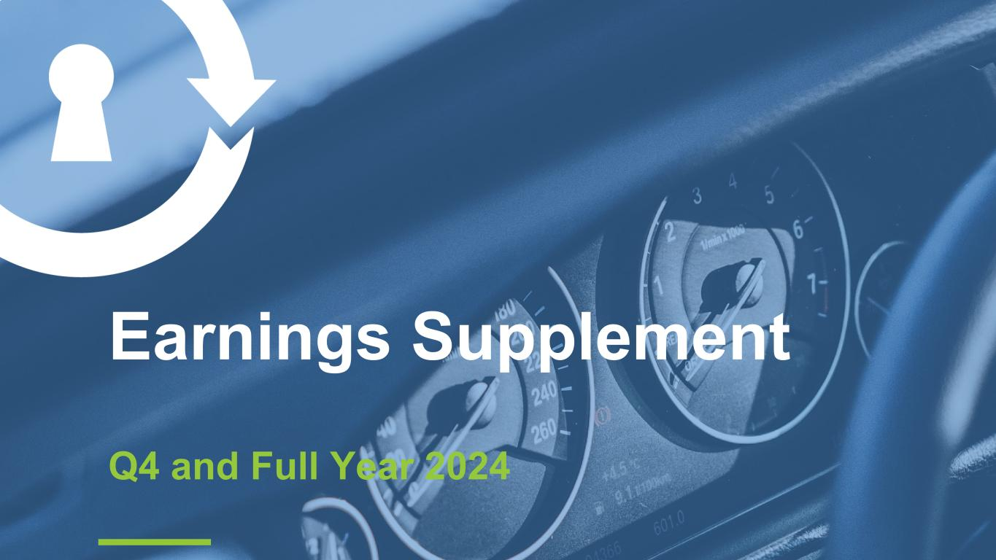

Earnings Supplement Q4 and Full Year 2024

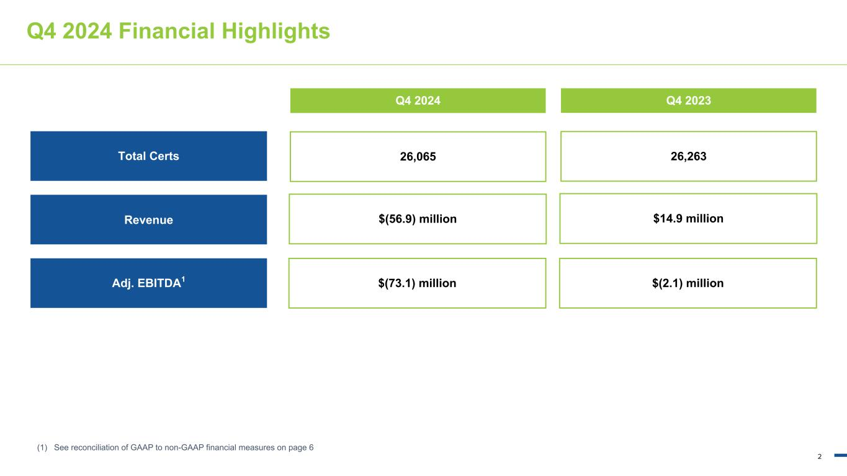
2 23, 159, 221 149, 201, 61 20, 83, 150 3, 102, 170 146, 192, 219 166, 166, 166 Q4 2024 Financial Highlights Q4 2024 (1) See reconciliation of GAAP to non-GAAP financial measures on page 6 Q4 2023 Revenue $(56.9) million $14.9 million Adj. EBITDA1 $(73.1) million $(2.1) million Total Certs 26,065 26,263

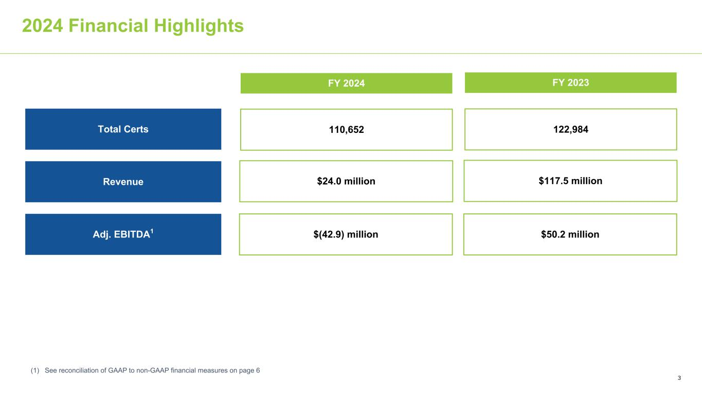
3 23, 159, 221 149, 201, 61 20, 83, 150 3, 102, 170 146, 192, 219 166, 166, 166 2024 Financial Highlights FY 2024 (1) See reconciliation of GAAP to non-GAAP financial measures on page 6 FY 2023 Revenue $24.0 million $117.5 million Adj. EBITDA1 $(42.9) million $50.2 million Total Certs 110,652 122,984

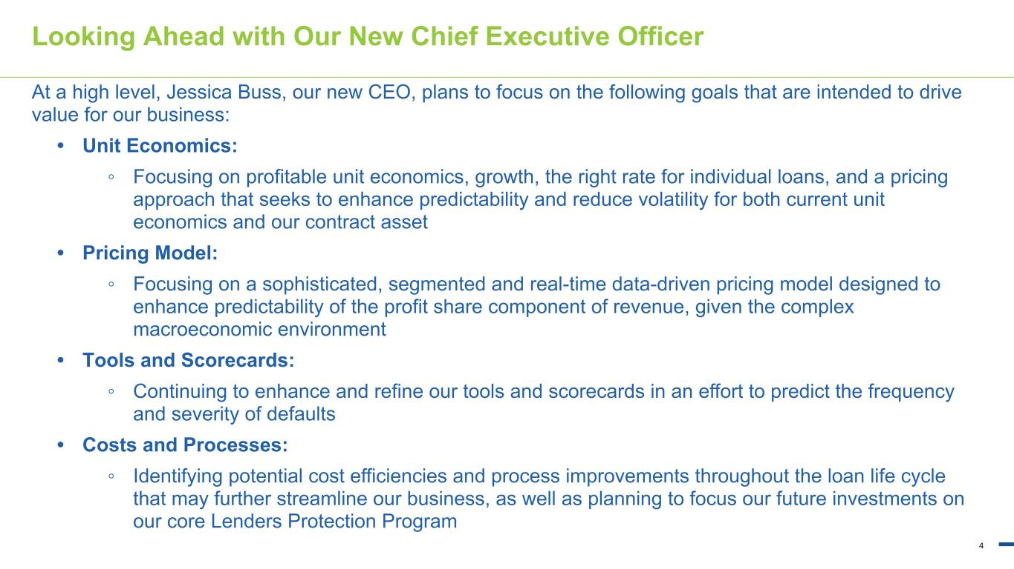
4 23, 159, 221 149, 201, 61 20, 83, 150 3, 102, 170 146, 192, 219 166, 166, 166 Looking Ahead with Our New Chief Executive Officer At a high level, Jessica Buss, our new CEO, plans to focus on the following goals that are intended to drive value for our business: • Unit Economics: ◦ Focusing on profitable unit economics, growth, the right rate for individual loans, and a pricing approach that seeks to enhance predictability and reduce volatility for both current unit economics and our contract asset • Pricing Model: ◦ Focusing on a sophisticated, segmented and real-time data-driven pricing model designed to enhance predictability of the profit share component of revenue, given the complex macroeconomic environment • Tools and Scorecards: ◦ Continuing to enhance and refine our tools and scorecards in an effort to predict the frequency and severity of defaults • Costs and Processes: ◦ Identifying potential cost efficiencies and process improvements throughout the loan life cycle that may further streamline our business, as well as planning to focus our future investments on our core Lenders Protection Program

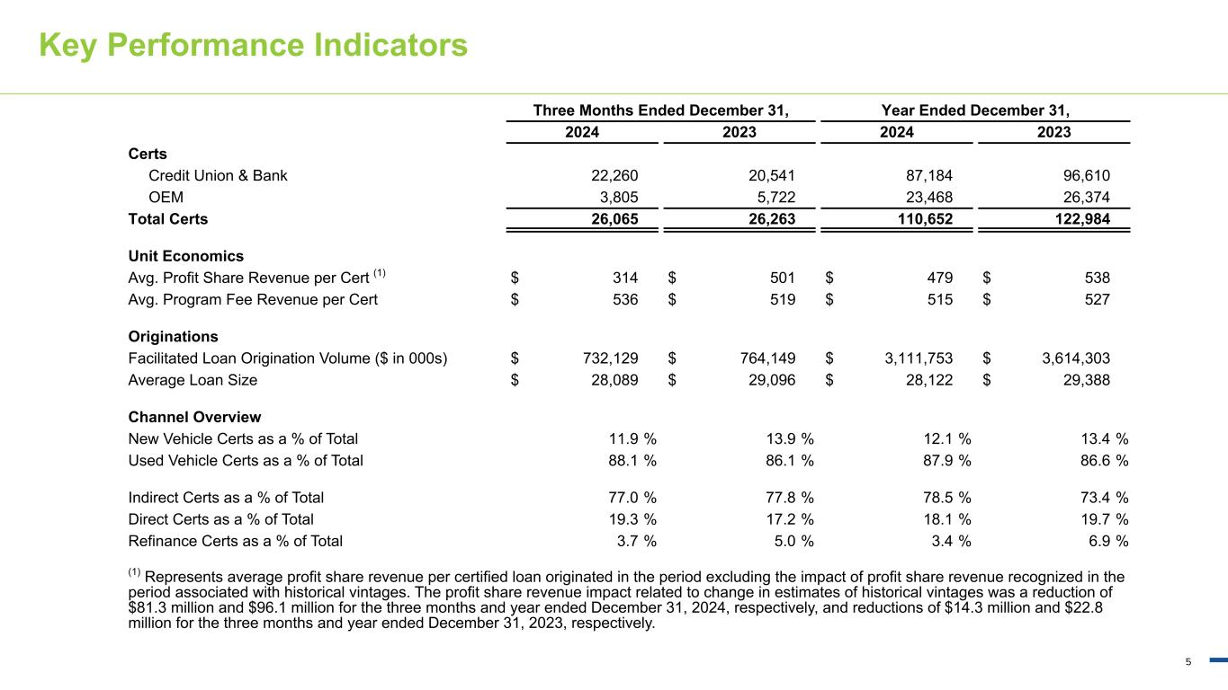
5 23, 159, 221 149, 201, 61 20, 83, 150 3, 102, 170 146, 192, 219 166, 166, 166 Key Performance Indicators Three Months Ended December 31, Year Ended December 31, 2024 2023 2024 2023 Certs Credit Union & Bank 22,260 20,541 87,184 96,610 OEM 3,805 5,722 23,468 26,374 Total Certs 26,065 26,263 110,652 122,984 Unit Economics Avg. Profit Share Revenue per Cert (1) $ 314 $ 501 $ 479 $ 538 Avg. Program Fee Revenue per Cert $ 536 $ 519 $ 515 $ 527 Originations Facilitated Loan Origination Volume ($ in 000s) $ 732,129 $ 764,149 $ 3,111,753 $ 3,614,303 Average Loan Size $ 28,089 $ 29,096 $ 28,122 $ 29,388 Channel Overview New Vehicle Certs as a % of Total 11.9 % 13.9 % 12.1 % 13.4 % Used Vehicle Certs as a % of Total 88.1 % 86.1 % 87.9 % 86.6 % Indirect Certs as a % of Total 77.0 % 77.8 % 78.5 % 73.4 % Direct Certs as a % of Total 19.3 % 17.2 % 18.1 % 19.7 % Refinance Certs as a % of Total 3.7 % 5.0 % 3.4 % 6.9 % (1) Represents average profit share revenue per certified loan originated in the period excluding the impact of profit share revenue recognized in the period associated with historical vintages. The profit share revenue impact related to change in estimates of historical vintages was a reduction of $81.3 million and $96.1 million for the three months and year ended December 31, 2024, respectively, and reductions of $14.3 million and $22.8 million for the three months and year ended December 31, 2023, respectively.

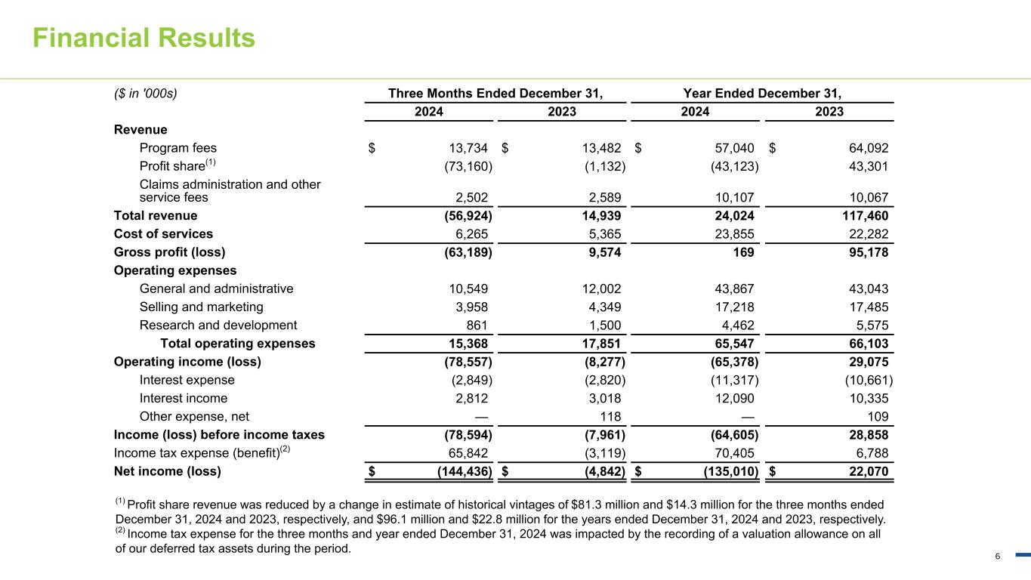
6 23, 159, 221 149, 201, 61 20, 83, 150 3, 102, 170 146, 192, 219 166, 166, 166 Financial Results ($ in '000s) Three Months Ended December 31, Year Ended December 31, 2024 2023 2024 2023 Revenue Program fees $ 13,734 $ 13,482 $ 57,040 $ 64,092 Profit share(1) (73,160) (1,132) (43,123) 43,301 Claims administration and other service fees 2,502 2,589 10,107 10,067 Total revenue (56,924) 14,939 24,024 117,460 Cost of services 6,265 5,365 23,855 22,282 Gross profit (loss) (63,189) 9,574 169 95,178 Operating expenses General and administrative 10,549 12,002 43,867 43,043 Selling and marketing 3,958 4,349 17,218 17,485 Research and development 861 1,500 4,462 5,575 Total operating expenses 15,368 17,851 65,547 66,103 Operating income (loss) (78,557) (8,277) (65,378) 29,075 Interest expense (2,849) (2,820) (11,317) (10,661) Interest income 2,812 3,018 12,090 10,335 Other expense, net — 118 — 109 Income (loss) before income taxes (78,594) (7,961) (64,605) 28,858 Income tax expense (benefit)(2) 65,842 (3,119) 70,405 6,788 Net income (loss) $ (144,436) $ (4,842) $ (135,010) $ 22,070 (1) Profit share revenue was reduced by a change in estimate of historical vintages of $81.3 million and $14.3 million for the three months ended December 31, 2024 and 2023, respectively, and $96.1 million and $22.8 million for the years ended December 31, 2024 and 2023, respectively. (2) Income tax expense for the three months and year ended December 31, 2024 was impacted by the recording of a valuation allowance on all of our deferred tax assets during the period.

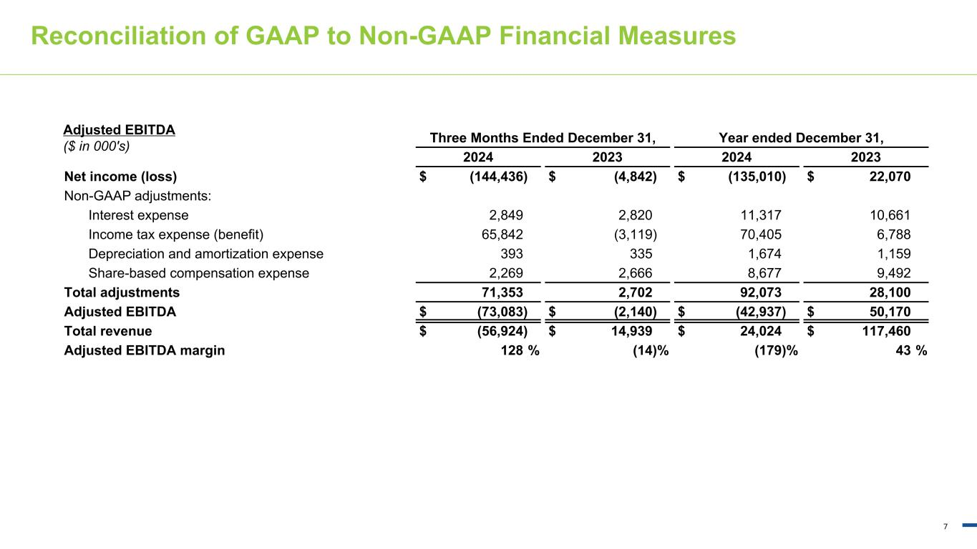
7 23, 159, 221 149, 201, 61 20, 83, 150 3, 102, 170 146, 192, 219 166, 166, 166 Reconciliation of GAAP to Non-GAAP Financial Measures Three Months Ended December 31, Year ended December 31, 2024 2023 2024 2023 Net income (loss) $ (144,436) $ (4,842) $ (135,010) $ 22,070 Non-GAAP adjustments: Interest expense 2,849 2,820 11,317 10,661 Income tax expense (benefit) 65,842 (3,119) 70,405 6,788 Depreciation and amortization expense 393 335 1,674 1,159 Share-based compensation expense 2,269 2,666 8,677 9,492 Total adjustments 71,353 2,702 92,073 28,100 Adjusted EBITDA $ (73,083) $ (2,140) $ (42,937) $ 50,170 Total revenue $ (56,924) $ 14,939 $ 24,024 $ 117,460 Adjusted EBITDA margin 128 % (14) % (179) % 43 % Adjusted EBITDA ($ in 000's)

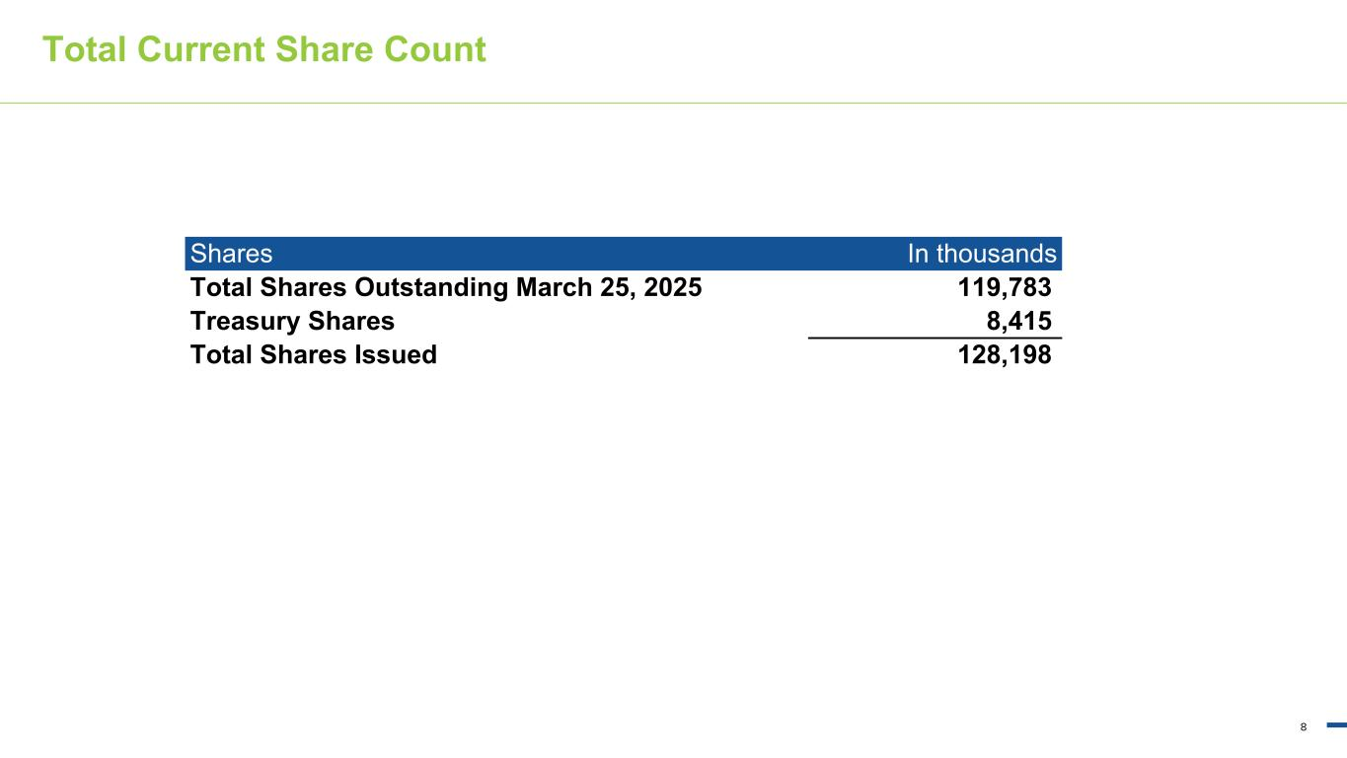
8 23, 159, 221 149, 201, 61 20, 83, 150 3, 102, 170 146, 192, 219 166, 166, 166 Total Current Share Count Shares In thousands Total Shares Outstanding March 25, 2025 119,783 Treasury Shares 8,415 Total Shares Issued 128,198

