UNITED STATES
SECURITIES AND EXCHANGE COMMISSION
Washington, D.C. 20549

FORM 8-K

CURRENT REPORT
PURSUANT TO SECTION 13 OR 15(d)
OF THE SECURITIES EXCHANGE ACT OF 1934
Date of Report (Date of earliest event reported): May 7, 2026

OPEN LENDING CORPORATION
(Exact name of registrant as specified in its charter)
Delaware |  |  | 001-39326 |  |  | 84-5031428
(State or other jurisdiction  of incorporation) |  |  | (Commission  File Number) |  |  | (IRS Employer  Identification No.)
1501 S. MoPac Expressway
Suite 450
Austin, Texas 78746
(Address of principal executive offices, including zip code)
Registrant’s telephone number, including area code: 512-892-0400
(Former name or former address, if changed since last report)
Check the appropriate box below if the Form 8-K filing is intended to simultaneously satisfy the filing obligation of the registrant under any of the following provisions:
☐ Written communications pursuant to Rule 425 under the Securities Act (17 CFR 230.425)
☐ Soliciting material pursuant to Rule 14a-12 under the Exchange Act (17 CFR 240.14a-12)
☐ Pre-commencement communications pursuant to Rule 14d-2(b) under the Exchange Act (17 CFR 240.14d-2(b))
☐ Pre-commencement communications pursuant to Rule 13e-4(c) under the Exchange Act (17 CFR 240.13e-4(c))

Securities registered pursuant to Section 12(b) of the Act:

Title of each class |  |  |  |  |  | Trading  Symbol(s) |  |  |  |  |  | Name of each exchange  on which registered
Common stock, par value $0.01 per share |  |  |  |  |  | LPRO |  |  |  |  |  | The Nasdaq Stock Market LLC
Indicate by check mark whether the registrant is an emerging growth company as defined in Rule 405 of the Securities Act of 1933 (§230.405 of this chapter) or Rule 12b-2 of the Securities Exchange Act of 1934 (§240.12b-2 of this chapter). Emerging growth company ☐
If an emerging growth company, indicate by check mark if the registrant has elected not to use the extended transition period for complying with any new or revised financial accounting standards provided pursuant to Section 13(a) of the Exchange Act. ☐

Item 2.02 Results of Operations and Financial Condition.
On May 7, 2026, Open Lending Corporation (the “Company”) issued a press release announcing its financial results for the fiscal quarter ended March 31, 2026. A copy of the press release and additional supplemental financial information are attached as Exhibits 99.1 and 99.2, respectively, to this Current Report on Form 8-K and are incorporated by reference herein.
The information furnished under this Item 2.02 and in the accompanying Exhibits 99.1 and 99.2 shall not be deemed “filed” for purposes of Section 18 of the Securities Exchange Act of 1934, as amended (the “Exchange Act”), or incorporated by reference in any filing under the Securities Act of 1933, as amended, or the Exchange Act regardless of any general incorporation language in such filing, unless expressly incorporated by specific reference in such filing.

Item 9.01 Financial Statements and Exhibits.
(d) Exhibits
99.1 |  |  | Earnings Release, dated May 7, 2026
99.2 |  |  | Earnings Supplement Q1 2026
104 |  |  | Cover Page Interactive Data File (embedded within the Inline XBRL document)

1

SIGNATURES
Pursuant to the requirements of the Securities Exchange Act of 1934, the registrant has duly caused this report to be signed on its behalf by the undersigned hereunto duly authorized.

OPEN LENDING CORPORATION
By: |  |  |  |  |  | /s/ Massimo Monaco
Name: |  |  |  |  |  | Massimo Monaco
Title: |  |  |  |  |  | Chief Financial Officer
Date: May 7, 2026

2
Exhibit 99.1

Open Lending Reports First Quarter 2026 Financial Results

AUSTIN, Texas, May 7, 2026 – Open Lending Corporation (Nasdaq: LPRO) (the “Company” or “Open Lending”), a leading provider of lending enablement and risk analytics solutions for financial institutions, today reported financial results for its first quarter ended March 31, 2026.
“We delivered solid execution in the first quarter, which represents another positive step in our transformation and reinforces the deliberate actions we have taken to build a fundamentally healthier and more profitable business,” said Jessica Buss, Chief Executive Officer of Open Lending. “We exceeded the high end of our certified loan guidance for the first quarter while improving the quality and mix of our certified loans.

“In addition, we continue to make solid progress on our key strategic initiatives, including Project Red Rocks and ApexOne Auto. With healthy application volumes combined with what we believe is the highest-quality portfolio we have seen in years, we believe we are well positioned to deliver sustainable, profitable growth for our shareholders in 2026 and beyond.”
Three Months Ended March 31, 2026 Highlights
•The Company facilitated 21,064 certified loans during the first quarter of 2026, compared to 27,638 certified loans in the first quarter of 2025.
•Total revenue was $20.5 million during the first quarter of 2026, compared to $24.4 million in the first quarter of 2025. The first quarter of 2026 was impacted by a $0.7 million reduction in estimated profit share revenues related to business in historic vintages as compared to a $0.9 million reduction in the first quarter of 2025.
•Gross profit was $15.6 million during the first quarter of 2026, compared to $18.3 million in the first quarter of 2025.
•Net loss was $0.5 million during the first quarter of 2026, compared to net income of $0.6 million in the first quarter of 2025.
•Adjusted EBITDA was $2.0 million during the first quarter of 2026, compared to $3.2 million in the first quarter of 2025.
Adjusted EBITDA is a non-GAAP financial measure. A reconciliation of this non-GAAP financial measure to its most directly comparable GAAP financial measure is provided in the financial table included at the end of this press release. An explanation of this measure and how it is calculated is also included under the heading “Non-GAAP Financial Measures.”
Business Highlights
•Credit unions and banks represented 19,000, or 90.2%, of certified loans in the first quarter of 2026, compared to 24,215, or 87.6%, in the first quarter of 2025.
•Average profit share revenue per certified loan was $363 in the first quarter of 2026, compared to $278 in the first quarter of 2025.
•Average program fee revenue per certified loan was $538 in the first quarter of 2026, compared to $550 in the first quarter of 2025.

Financial Outlook
The Company is currently providing the following financial outlook for the second quarter and full year 2026:
•Total certified loans expected to be between 22,000 and 25,000 for the second quarter of 2026.
•Total certified loans expected to be between 100,000 and 110,000 for the full year 2026.
•Adjusted EBITDA expected to be between $25 to $29 million for the full year 2026.

The guidance provided includes forward-looking statements within the meaning of U.S. securities laws. See “Forward-Looking Statements” below.

Open Lending will host a conference call to discuss the first quarter financial results on May 7, 2026 at 5:00 pm ET. The conference call will be webcast live from the Company's investor relations website at https://investors.openlending.com/ under the “Events” section. The conference call can also be accessed live over the phone by dialing (800) 343-5172, or for international callers (203) 518-9856. An archive of the webcast will be available at the same location on the website shortly after the call has concluded.
Share Repurchase Program Extension
On April 30, 2026, the Board of Directors increased the maximum aggregate amount of our previously authorized share repurchase program allowing the Company to repurchase shares of the Company’s outstanding common stock (the “Share Repurchase Program”) from $25.0 million to $50.0 million and extended the expiration date of the Share Repurchase Program from May 1, 2026 to May 1, 2027. Repurchases may be made at management’s discretion from time to time on the open market. The Share Repurchase Program may be suspended, amended, or discontinued at any time. As of March 31, 2026, we had $20.1 million available under the Share Repurchase Program.
About Open Lending
Open Lending (Nasdaq: LPRO) provides loan analytics, risk-based pricing, risk modeling and default insurance to auto lenders throughout the United States. For 25 years, we have been empowering financial institutions to create profitable auto loan portfolios with less risk and more reward. For more information, please visit www.openlending.com.
Forward-Looking Statements
This press release includes certain statements that are not historical facts but are forward-looking statements for purposes of the safe harbor provisions under the United States Private Securities Litigation Reform Act of 1995, including statements related to the Company's new loan measures, lender profitability, volatility, market trends, consumer behavior and demand for automotive loans, as well as future financial or operating performance under the heading "Financial Outlook" above. Forward-looking statements generally are accompanied by words such as “believe,” “may,” “will,” “estimate,” “continue,” “anticipate,” “intend,” “expect,” “should,” “would,” “plan,” “predict,” “potential,” “seem,” “seek,” “future,” “outlook,” “on track,” and similar expressions that predict or indicate future events or trends or that are not statements of historical matters. These statements are based on various assumptions and on the current expectations of the Company’s management and are not guarantees of actual results. Actual results may differ materially from those expressed or implied by these forward-looking statements due to a number of risks and uncertainties, including general economic, market, political and business conditions; applicable taxes, inflation, tariffs, supply chain disruptions including global hostilities and responses thereto, interest rates and the regulatory environment; the outcome of judicial proceedings to which Open Lending may become a party; and other risks discussed in our filings with the Securities and Exchange Commission, including our Annual Report on Form 10-K for the year ended December 31, 2025. There may be additional risks that the Company presently does not know or that it currently believes are immaterial that could also cause actual results to differ from those contained in the forward-looking statements. In addition, forward-looking statements reflect the Company’s expectations, plans or forecasts of future events and views as of the date of this press release. Subsequent events and developments may cause the Company's assessments to change, but, the Company specifically disclaims any obligation to update these forward-looking statements. These forward-looking statements should not be relied upon as representing the Company’s assessments as of any date subsequent to the date of this press release. Accordingly, undue reliance should not be placed upon the forward-looking statements.
Non-GAAP Financial Measures
The non-GAAP financial measures included in this press release are financial information that has not been prepared in accordance with GAAP. Adjusted EBITDA and Adjusted EBITDA margin are used by the Company to evaluate its operating performance, generate future operating plans, and make strategic decisions, including those relating to operating expenses and the allocation of internal resources. Accordingly, the Company believes these measures provide useful information to investors and others in understanding and evaluating its operating results in the same manner as its management and board of directors. In addition, the Company believes these measures provide useful analysis for period-to-period comparisons of its business, as they remove the effect of certain non-cash items and certain non-recurring variable charges.
Beginning in the quarter ended June 30, 2025, the Company updated the presentation of Adjusted EBITDA to exclude interest income as the Company believes the exclusion of interest income better aligns its presentation with comparable companies. In addition, beginning in the quarter ended September 30, 2025, the Company updated the presentation of Adjusted EBITDA to exclude certain other non-recurring expenses that do not contribute directly to

management’s evaluation of its operating results. Prior periods presented have been conformed to the current period presentation.
Adjusted EBITDA is defined as GAAP net income (loss) excluding interest expense (income), income tax expense (benefit), depreciation expense of property and equipment, amortization expense of capitalized software development costs, share-based compensation expense, loss on extinguishment of debt and certain other non-recurring expenses that do not contribute directly to management’s evaluation of its operating results. Adjusted EBITDA margin is defined as Adjusted EBITDA expressed as a percentage of total revenue.
Non-GAAP financial measures should not be considered in isolation from, or as a substitute for, financial information prepared in accordance with GAAP. Investors are encouraged to review the reconciliation of non-GAAP financial measures to their most directly comparable GAAP financial measure provided in the financial statement tables included below in this press release.
Investor Relations Contact:
InvestorRelations@openlending.com

OPEN LENDING CORPORATION
Consolidated Balance Sheets
(Unaudited)
(In thousands, except share data)

 |  |  |  |  |  | March 31, 2026 |  |  |  |  |  | December 31, 2025
Assets
Current assets
Cash and cash equivalents |  |  |  |  |  | $ | 173,308 |  |  |  |  | $ | 176,614
Restricted cash |  |  |  |  |  | 11,643 |  |  |  |  |  | 11,604
Accounts receivable, net |  |  |  |  |  | 4,754 |  |  |  |  |  | 3,653
Current contract assets, net |  |  |  |  |  | 21,561 |  |  |  |  |  | 22,186
Income tax receivable |  |  |  |  |  | 1,003 |  |  |  |  |  | 3,214
Other current assets |  |  |  |  |  | 5,859 |  |  |  |  |  | 5,416
Total current assets |  |  |  |  |  | 218,128 |  |  |  |  |  | 222,687
Property and equipment, net |  |  |  |  |  | 399 |  |  |  |  |  | 458
Capitalized software development costs, net |  |  |  |  |  | 3,816 |  |  |  |  |  | 4,046
Operating lease right-of-use assets, net |  |  |  |  |  | 2,850 |  |  |  |  |  | 3,063
Contract assets |  |  |  |  |  | 2,381 |  |  |  |  |  | 2,893
Other assets |  |  |  |  |  | 3,513 |  |  |  |  |  | 3,532
Total assets |  |  |  |  |  | $ | 231,087 |  |  |  |  | $ | 236,679
Liabilities and stockholders’ equity
Current liabilities
Accounts payable |  |  |  |  |  | $ | 543 |  |  |  |  | $ | 446
Accrued expenses |  |  |  |  |  | 5,960 |  |  |  |  |  | 8,699
Current portion of debt |  |  |  |  |  | 7,500 |  |  |  |  |  | 7,500
Third-party claims administration liability |  |  |  |  |  | 11,677 |  |  |  |  |  | 11,706
Current portion of excess profit share receipts |  |  |  |  |  | 20,506 |  |  |  |  |  | 18,672
Other current liabilities |  |  |  |  |  | 2,951 |  |  |  |  |  | 2,235
Total current liabilities |  |  |  |  |  | 49,137 |  |  |  |  |  | 49,258
Long-term debt, net of deferred financing costs |  |  |  |  |  | 75,444 |  |  |  |  |  | 77,266
Operating lease liabilities |  |  |  |  |  | 2,133 |  |  |  |  |  | 2,382
Excess profit share receipts |  |  |  |  |  | 24,767 |  |  |  |  |  | 27,574
Other liabilities |  |  |  |  |  | 4,291 |  |  |  |  |  | 5,239
Total liabilities |  |  |  |  |  | 155,772 |  |  |  |  |  | 161,719
Stockholders’ equity
Preferred stock, $0.01 par value; 10,000,000 shares authorized and none issued and outstanding |  |  |  |  |  | — |  |  |  |  |  | —
Common stock, $0.01 par value; 550,000,000 shares authorized, 128,198,185 shares issued and 118,217,082 shares outstanding as of March 31, 2026 and 128,198,185 shares issued and 117,660,648 shares outstanding as of December 31, 2025 |  |  |  |  |  | 1,282 |  |  |  |  |  | 1,282
Additional paid-in capital |  |  |  |  |  | 491,954 |  |  |  |  |  | 497,663
Accumulated deficit |  |  |  |  |  | (333,455) |  |  |  |  |  | (332,995)
Treasury stock at cost, 9,981,103 shares at March 31, 2026 and 10,537,537 shares at December 31, 2025 |  |  |  |  |  | (84,466) |  |  |  |  |  | (90,990)
Total stockholders’ equity |  |  |  |  |  | 75,315 |  |  |  |  |  | 74,960
Total liabilities and stockholders’ equity |  |  |  |  |  | $ | 231,087 |  |  |  |  | $ | 236,679

OPEN LENDING CORPORATION
Consolidated Statements of Operations
(Unaudited)
(In thousands, except per share data)

Three Months Ended
March 31,
 |  |  | 2026 |  |  |  |  |  | 2025
Revenue
Program fees |  |  | $ | 11,374 |  |  |  |  | $ | 15,210
Profit share |  |  | 6,950 |  |  |  |  |  | 6,730
Claims administration and other service fees |  |  | 2,167 |  |  |  |  |  | 2,453
Total revenue |  |  | 20,491 |  |  |  |  |  | 24,393
Cost of services |  |  | 4,854 |  |  |  |  |  | 6,084
Gross profit |  |  | 15,637 |  |  |  |  |  | 18,309
Operating expenses
General and administrative |  |  | 11,585 |  |  |  |  |  | 10,898
Selling and marketing |  |  | 2,918 |  |  |  |  |  | 4,382
Research and development |  |  | 1,767 |  |  |  |  |  | 2,267
Total operating expenses |  |  | 16,270 |  |  |  |  |  | 17,547
Operating income (loss) |  |  | (633) |  |  |  |  |  | 762
Interest expense |  |  | (1,329) |  |  |  |  |  | (2,589)
Interest income |  |  | 1,492 |  |  |  |  |  | 2,500
Income (loss) before income taxes |  |  | (470) |  |  |  |  |  | 673
Income tax expense (benefit) |  |  | (10) |  |  |  |  |  | 56
Net income (loss) |  |  | $ | (460) |  |  |  |  | $ | 617
Net income (loss) per common share
Basic |  |  | $ | — |  |  |  |  | $ | 0.01
Diluted |  |  | $ | — |  |  |  |  | $ | 0.01
Weighted average common shares outstanding
Basic |  |  | 117,778 |  |  |  |  |  | 119,451
Diluted |  |  | 117,778 |  |  |  |  |  | 119,629

OPEN LENDING CORPORATION
Consolidated Statements of Cash Flows
(Unaudited)
(In thousands)

Three Months Ended
March 31,
 |  |  | 2026 |  |  |  |  |  | 2025
Cash flows from operating activities
Net income (loss) |  |  | $ | (460) |  |  |  |  | $ | 617
Adjustments to reconcile net income (loss) to net cash used in operating activities:
Share-based compensation |  |  | 1,131 |  |  |  |  |  | 1,846
Depreciation and amortization |  |  | 656 |  |  |  |  |  | 544
Amortization of deferred financing cost |  |  | 70 |  |  |  |  |  | 103
Non-cash operating lease cost |  |  | 213 |  |  |  |  |  | 198
Other |  |  | 34 |  |  |  |  |  | 144
Changes in operating assets & liabilities:
Accounts receivable, net |  |  | (1,104) |  |  |  |  |  | (495)
Contract assets, net |  |  | 1,131 |  |  |  |  |  | (14,778)
Excess profit share receipts |  |  | (972) |  |  |  |  |  | 9,000
Other current and non-current assets |  |  | (465) |  |  |  |  |  | 70
Accounts payable |  |  | 97 |  |  |  |  |  | (600)
Accrued expenses |  |  | (2,785) |  |  |  |  |  | 2,454
Income tax receivable, net |  |  | 2,203 |  |  |  |  |  | 39
Operating lease liabilities |  |  | (218) |  |  |  |  |  | (185)
Third-party claims administration liability |  |  | (29) |  |  |  |  |  | (137)
Other current and non-current liabilities |  |  | (266) |  |  |  |  |  | (2,658)
Net cash used in operating activities |  |  | (764) |  |  |  |  |  | (3,838)
Cash flows from investing activities
Purchase of property and equipment |  |  | — |  |  |  |  |  | (45)
Capitalized software development costs |  |  | (289) |  |  |  |  |  | (561)
Net cash used in investing activities |  |  | (289) |  |  |  |  |  | (606)
Cash flows from financing activities
Payments on term loans |  |  | (1,875) |  |  |  |  |  | (1,875)
Shares withheld for taxes related to restricted stock units |  |  | (339) |  |  |  |  |  | (758)
Net cash used in financing activities |  |  | (2,214) |  |  |  |  |  | (2,633)
Net change in cash and cash equivalents and restricted cash |  |  | (3,267) |  |  |  |  |  | (7,077)
Cash and cash equivalents and restricted cash at the beginning of the period |  |  | 188,218 |  |  |  |  |  | 253,924
Cash and cash equivalents and restricted cash at the end of the period |  |  | $ | 184,951 |  |  |  |  | $ | 246,847
Supplemental disclosure of cash flow information:
Interest paid |  |  | $ | 1,263 |  |  |  |  | $ | 2,489
Income tax paid (refunded), net |  |  | (2,213) |  |  |  |  |  | 16

OPEN LENDING CORPORATION
Reconciliation of GAAP to Non-GAAP Financial Measures
(Unaudited)
(In thousands, except margin data)

Three Months Ended
March 31,
 |  |  | 2026 |  |  |  |  |  | 2025
Net income (loss) |  |  | $ | (460) |  |  |  |  | $ | 617
Non-GAAP adjustments:
Interest (income) expense, net |  |  | (163) |  |  |  |  |  | 89
Income tax expense (benefit) |  |  | (10) |  |  |  |  |  | 56
Depreciation and amortization expense |  |  | 656 |  |  |  |  |  | 544
Share-based compensation |  |  | 1,131 |  |  |  |  |  | 1,846
Other non-recurring expense |  |  | 822 |  |  |  |  |  | —
Total adjustments |  |  | 2,436 |  |  |  |  |  | 2,535
Adjusted EBITDA |  |  | $ | 1,976 |  |  |  |  | $ | 3,152
Net income (loss) margin |  |  | (2) |  | % |  |  |  | 3 |  | %
Adjusted EBITDA margin |  |  | 10 |  | % |  |  |  | 13 |  | %



Earnings Supplement Q1 2026

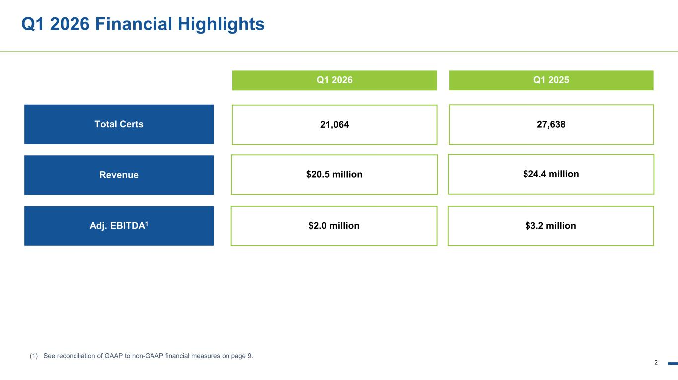
2 Q1 2026 Financial Highlights Q1 2026 (1) See reconciliation of GAAP to non-GAAP financial measures on page 9. Q1 2025 Revenue $20.5 million $24.4 million Adj. EBITDA1 $2.0 million $3.2 million Total Certs 21,064 27,638

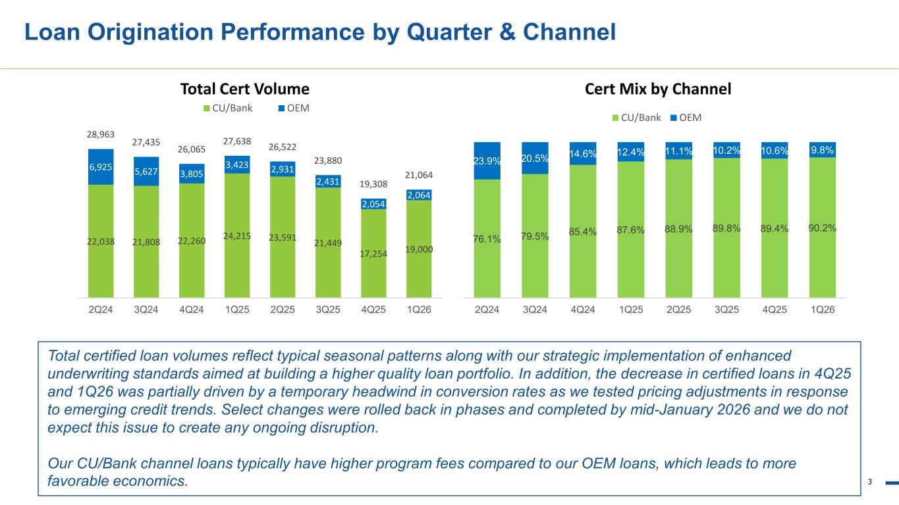
3 Loan Origination Performance by Quarter & Channel Total certified loan volumes reflect typical seasonal patterns along with our strategic implementation of enhanced underwriting standards aimed at building a higher quality loan portfolio. In addition, the decrease in certified loans in 4Q25 and 1Q26 was partially driven by a temporary headwind in conversion rates as we tested pricing adjustments in response to emerging credit trends. Select changes were rolled back in phases and completed by mid-January 2026 and we do not expect this issue to create any ongoing disruption. Our CU/Bank channel loans typically have higher program fees compared to our OEM loans, which leads to more favorable economics. 22,038 21,808 22,260 24,215 23,591 21,449 17,254 19,000 6,925 5,627 3,805 3,423 2,931 2,431 2,054 2,064 28,963 27,435 26,065 27,638 26,522 23,880 19,308 21,064 2Q24 3Q24 4Q24 1Q25 2Q25 3Q25 4Q25 1Q26 Total Cert Volume CU/Bank OEM 76.1% 79.5% 85.4% 87.6% 88.9% 89.8% 89.4% 90.2% 23.9% 20.5% 14.6% 12.4% 11.1% 10.2% 10.6% 9.8% 2Q24 3Q24 4Q24 1Q25 2Q25 3Q25 4Q25 1Q26 Cert Mix by Channel CU/Bank OEM

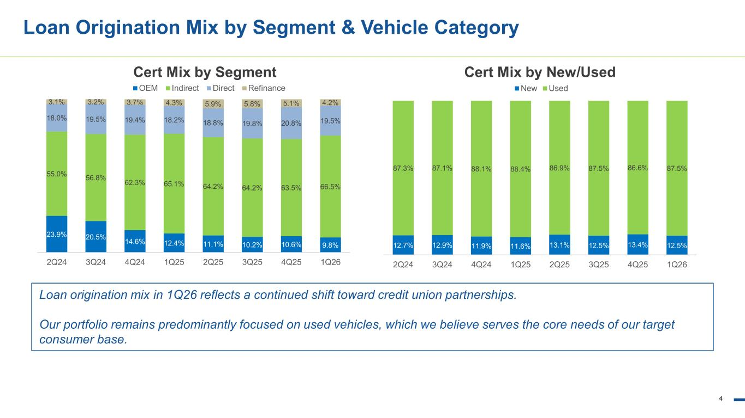
4 Loan Origination Mix by Segment & Vehicle Category Loan origination mix in 1Q26 reflects a continued shift toward credit union partnerships. Our portfolio remains predominantly focused on used vehicles, which we believe serves the core needs of our target consumer base. 23.9% 20.5% 14.6% 12.4% 11.1% 10.2% 10.6% 9.8% 55.0% 56.8% 62.3% 65.1% 64.2% 64.2% 63.5% 66.5% 18.0% 19.5% 19.4% 18.2% 18.8% 19.8% 20.8% 19.5% 3.1% 3.2% 3.7% 4.3% 5.9% 5.8% 5.1% 4.2% 2Q24 3Q24 4Q24 1Q25 2Q25 3Q25 4Q25 1Q26 Cert Mix by Segment OEM Indirect Direct Refinance 12.7% 12.9% 11.9% 11.6% 13.1% 12.5% 13.4% 12.5% 87.3% 87.1% 88.1% 88.4% 86.9% 87.5% 86.6% 87.5% 2Q24 3Q24 4Q24 1Q25 2Q25 3Q25 4Q25 1Q26 Cert Mix by New/Used New Used

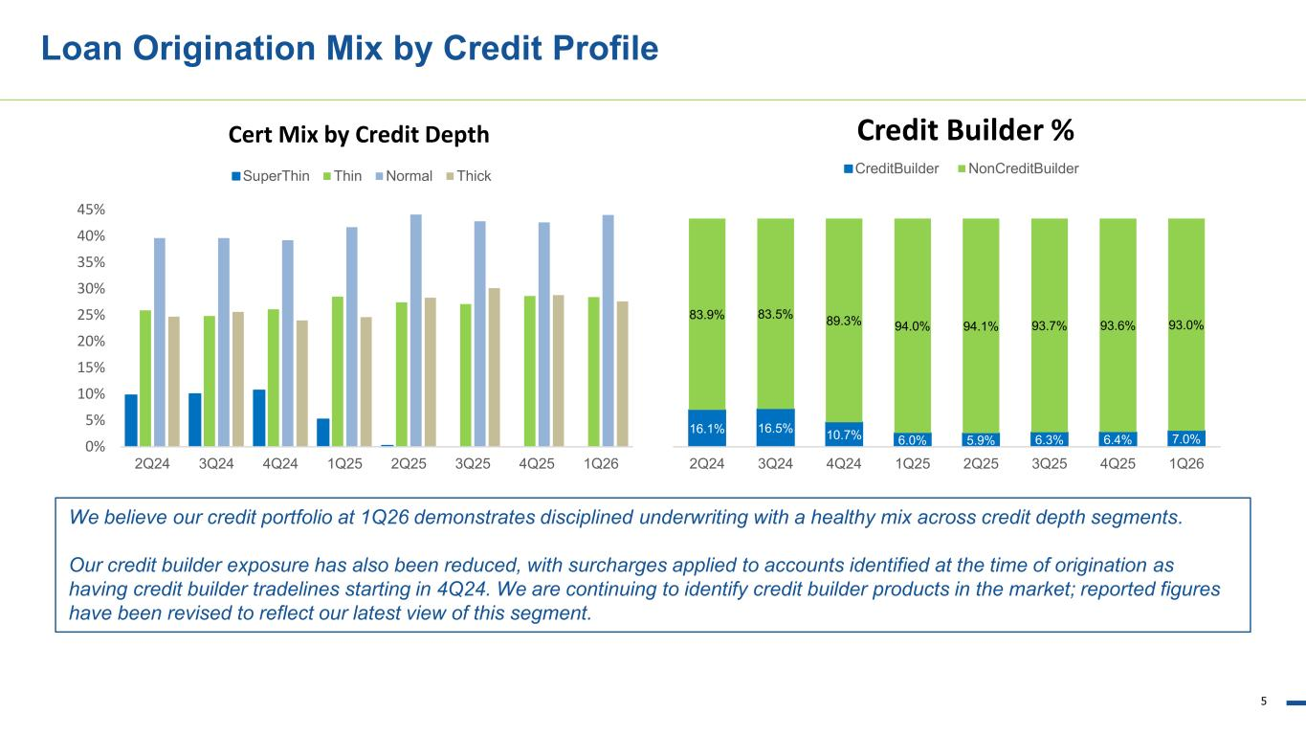
5 We believe our credit portfolio at 1Q26 demonstrates disciplined underwriting with a healthy mix across credit depth segments. Our credit builder exposure has also been reduced, with surcharges applied to accounts identified at the time of origination as having credit builder tradelines starting in 4Q24. We are continuing to identify credit builder products in the market; reported figures have been revised to reflect our latest view of this segment. Loan Origination Mix by Credit Profile 0% 5% 10% 15% 20% 25% 30% 35% 40% 45% 2Q24 3Q24 4Q24 1Q25 2Q25 3Q25 4Q25 1Q26 Cert Mix by Credit Depth SuperThin Thin Normal Thick 16.1% 16.5% 10.7% 6.0% 5.9% 6.3% 6.4% 7.0% 83.9% 83.5% 89.3% 94.0% 94.1% 93.7% 93.6% 93.0% 2Q24 3Q24 4Q24 1Q25 2Q25 3Q25 4Q25 1Q26 Credit Builder % CreditBuilder NonCreditBuilder

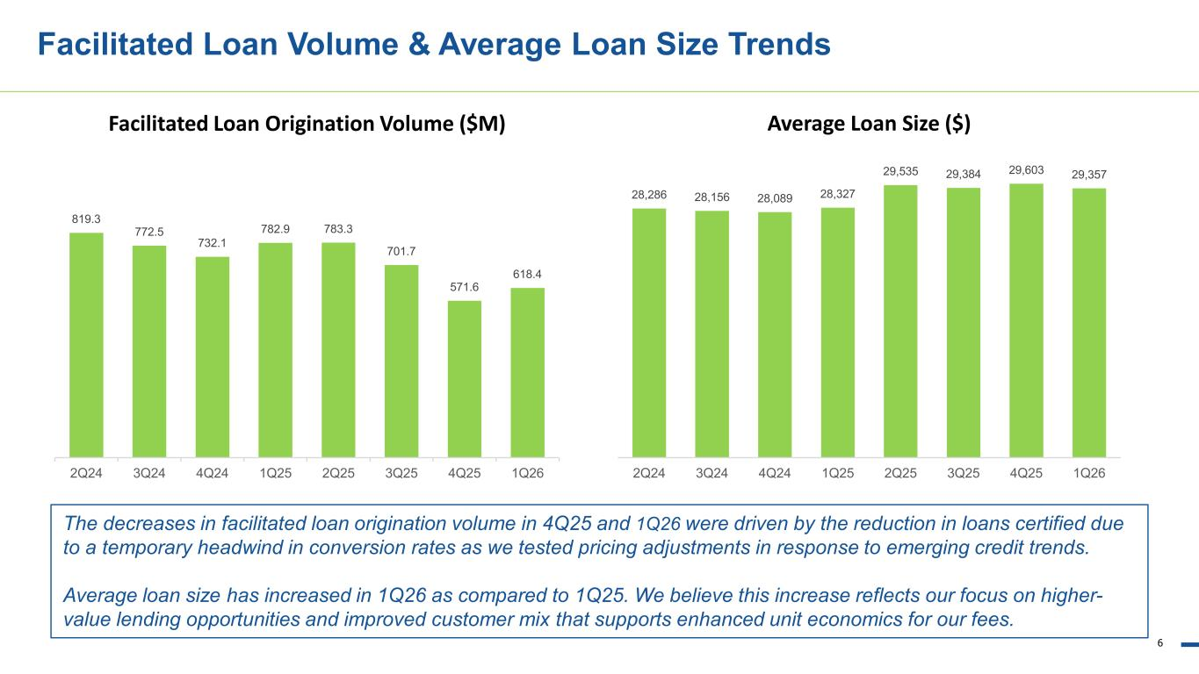
6 Facilitated Loan Volume & Average Loan Size Trends The decreases in facilitated loan origination volume in 4Q25 and 1Q26 were driven by the reduction in loans certified due to a temporary headwind in conversion rates as we tested pricing adjustments in response to emerging credit trends. Average loan size has increased in 1Q26 as compared to 1Q25. We believe this increase reflects our focus on higher- value lending opportunities and improved customer mix that supports enhanced unit economics for our fees. 28,286 28,156 28,089 28,327 29,535 29,384 29,603 29,357 2Q24 3Q24 4Q24 1Q25 2Q25 3Q25 4Q25 1Q26 Average Loan Size ($) 819.3 772.5 732.1 782.9 783.3 701.7 571.6 618.4 2Q24 3Q24 4Q24 1Q25 2Q25 3Q25 4Q25 1Q26 Facilitated Loan Origination Volume ($M)

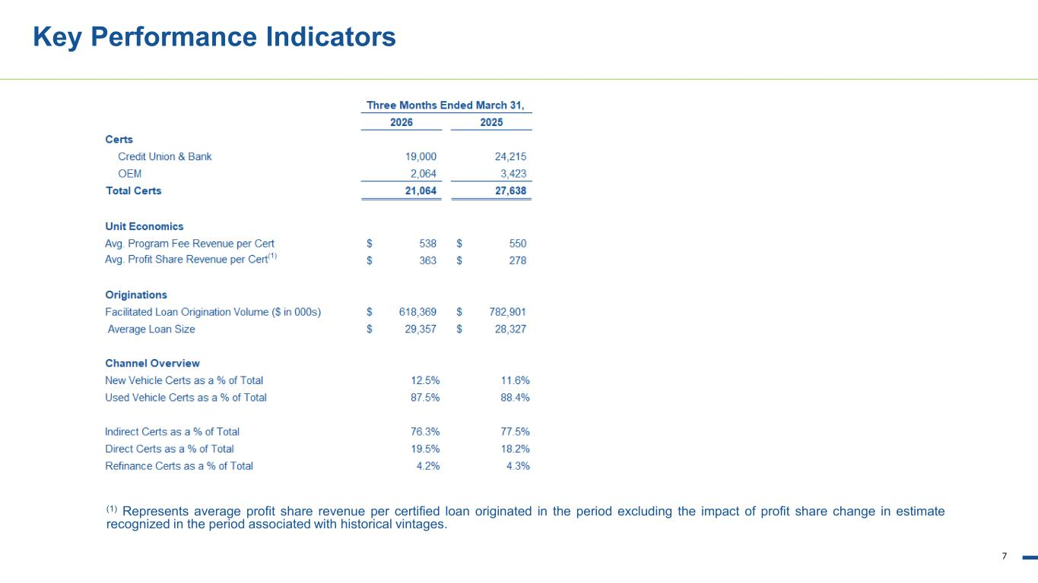
7 Key Performance Indicators (1) Represents average profit share revenue per certified loan originated in the period excluding the impact of profit share change in estimate recognized in the period associated with historical vintages.

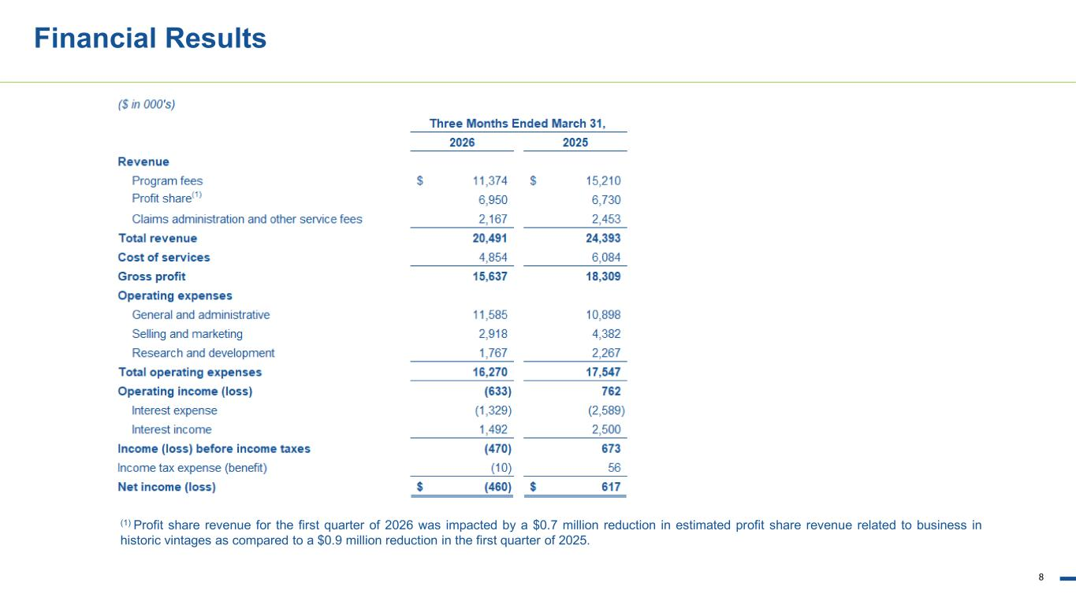
8 Financial Results (1) Profit share revenue for the first quarter of 2026 was impacted by a $0.7 million reduction in estimated profit share revenue related to business in historic vintages as compared to a $0.9 million reduction in the first quarter of 2025.

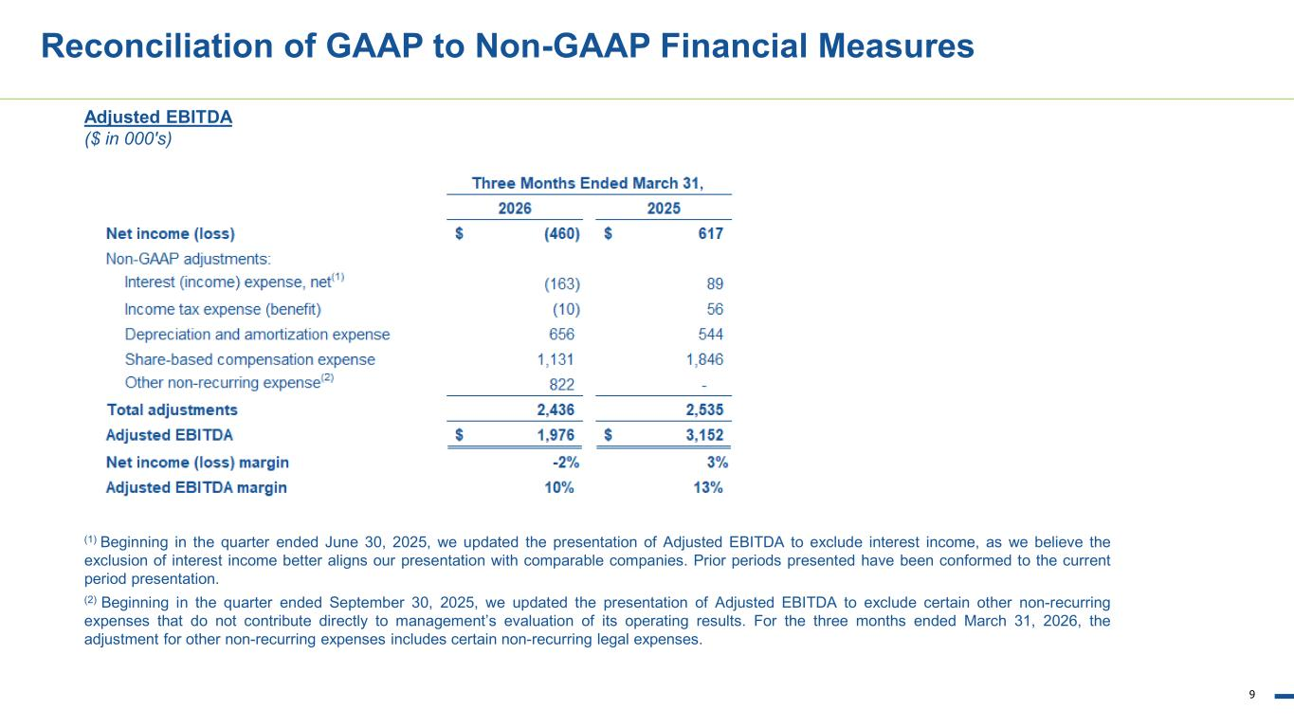
9 Reconciliation of GAAP to Non-GAAP Financial Measures Adjusted EBITDA ($ in 000's) (1) Beginning in the quarter ended June 30, 2025, we updated the presentation of Adjusted EBITDA to exclude interest income, as we believe the exclusion of interest income better aligns our presentation with comparable companies. Prior periods presented have been conformed to the current period presentation. (2) Beginning in the quarter ended September 30, 2025, we updated the presentation of Adjusted EBITDA to exclude certain other non-recurring expenses that do not contribute directly to management’s evaluation of its operating results. For the three months ended March 31, 2026, the adjustment for other non-recurring expenses includes certain non-recurring legal expenses.

