UNITED STATES

SECURITIES AND EXCHANGE COMMISSION
Washington, D.C. 20549

SCHEDULE 14D-9

SOLICITATION/RECOMMENDATION STATEMENT

UNDER SECTION 14(d)(4) OF THE SECURITIES EXCHANGE ACT OF 1934

OPEN LENDING CORPORATION

(Name of Subject Company)

OPEN LENDING CORPORATION

(Name of Persons Filing Statement)

Common stock, $0.01 par value per share

(Title of Class of Securities)

68373J104

(CUSIP Number of Class of Securities)

Ben Massey

General Counsel and Corporate Secretary

1501 S. MoPac Expressway, Suite 450

Austin, Texas 78746

(512) 892-0400
(Name, Address and Telephone Number of Person Authorized to Receive Notices and Communications

on Behalf of the Persons Filing Statement)

Copy to:

Randi C. Lesnick

Braden McCurrach

Jones Day

250 Vesey Street

New York, New York 10281

(212) 326-3939

- Check the box if the filing relates solely to preliminary communications made before the commencement of a tender offer.

This Schedule 14D-9 filing consists of certain communications relating to the proposed acquisition of Open Lending Corporation, a Delaware corporation (the “Company”), by ANV Group Holdings Ltd., a private limited company incorporated under the laws of England and Wales (“Parent”), pursuant to the terms and subject to the conditions of an Agreement and Plan of Merger, dated as of June 15, 2026 (the “Merger Agreement”), by and among the Company, Parent and Lakers Acquisition Sub, Inc., a Delaware corporation and indirect wholly owned subsidiary of Parent (“Merger Sub”). Pursuant to the Merger Agreement, Merger Sub will commence a tender offer (the “Offer”) to purchase any and all of the issued and outstanding shares (each, a “Share” and collectively, the “Shares”) of the Company’s common stock, par value $0.01 per share (“Common Stock”) and, as soon as practicable following consummation of the Offer, Merger Sub will merge with and into the Company (the “Merger”), with the Company surviving the Merger as an indirect wholly owned subsidiary of Parent.

This Schedule 14D-9 filing consists of the following documents relating to the Offer and the Merger:

- Exhibit 99.1: Internal Associate Announcement

- Exhibit 99.2: Letter to Customers

- Exhibit 99.3: Customer and Partner Talking Points

- Exhibit 99.4: Employee FAQs

- Exhibit 99.5: All Hands Meeting Presentation

- Exhibit 99.6: Postings by the Company and Jessica Buss, Chief Executive Officer of the Company, via LinkedIn

The materials listed above were first used or made available on June 16, 2026.

The information set forth under Items 1.01, 7.01 and 9.01 of the Current Report on Form 8-K filed by the Company on June 16, 2026 (including all exhibits attached thereto) is incorporated herein by reference.

Additional Information and Where to Find It

The Offer has not yet commenced. This document is for informational purposes only and is neither an offer to purchase nor a solicitation of an offer to sell Open Lending’s securities, nor is it a substitute for the Offer materials that Parent and Merger Sub will file with the U.S. Securities and Exchange Commission (the “SEC”) upon commencement of the Offer. A solicitation and offer to buy shares of Open Lending’s common stock will only be made pursuant to the Offer materials that Parent and Merger Sub intend to file with the SEC. At the time the Offer is commenced, Parent and Merger Sub will file Offer materials on Schedule TO with the SEC, and Open Lending will thereafter file a solicitation/recommendation statement on Schedule 14D-9 with the SEC with respect to the Offer. THE OFFER MATERIALS (INCLUDING AN OFFER TO PURCHASE, A RELATED LETTER OF TRANSMITTAL AND CERTAIN OTHER OFFER DOCUMENTS) AND THE SOLICITATION/RECOMMENDATION STATEMENT WILL CONTAIN IMPORTANT INFORMATION ABOUT THE PROPOSED TRANSACTION AND THE PARTIES THERETO. INVESTORS AND STOCKHOLDERS OF THE COMPANY ARE URGED TO READ THESE DOCUMENTS CAREFULLY WHEN THEY BECOME AVAILABLE (AND EACH AS IT MAY BE AMENDED OR SUPPLEMENTED FROM TIME TO TIME) BECAUSE THEY WILL CONTAIN IMPORTANT INFORMATION THAT INVESTORS AND STOCKHOLDERS OF OPEN LENDING SHOULD CONSIDER BEFORE MAKING ANY DECISION REGARDING TENDERING THEIR SHARES OF COMMON STOCK IN THE OFFER. The Offer materials (including the Offer to Purchase and the related Letter of Transmittal), as well as the solicitation/recommendation statement, will be made available to all stockholders of Open Lending at no expense to them at Open Lending’s website at www.openlending.com and (once they become available) will be mailed to Open Lending’s stockholders free of charge. The information contained in, or that can be accessed through, Open Lending’s website is not a part of, or incorporated by reference herein. The Offer materials (including the Offer to Purchase and the related Letter of Transmittal), as well as the solicitation/recommendation statement, will also be made available for free on the SEC’s website at www.sec.gov. Open Lending also files annual, quarterly and current reports, proxy statements and other information with the SEC. You may read any reports, statements or other information filed by Open Lending with the SEC for free on the SEC’s website at www.sec.gov.

Cautionary Note Regarding Forward-Looking Statements

This document, including the exhibits attached hereto and incorporated herein, contains forward-looking statements. Any statements that are not statements of historical fact are forward-looking statements. Generally, these statements may be identified by the use of words such as “may,” “will,” “should,” “expects,” “plans,” “anticipates,” “could,” “intends,” “targets,” “projects,” “contemplates,” “believes,” “estimates,” “forecasts,” “predicts,” or “continue,” or the negative of these words or other similar terms. These forward-looking statements are based on a number of assumptions that could ultimately prove inaccurate. Forward-looking statements made herein with respect to the Offer, the Merger and related transactions, including, for example, the anticipated timing of the completion of the Offer and the Merger and the potential benefits of the Merger, reflect management’s current analysis of existing information and are subject to various risks and uncertainties. As a result, undue reliance should not be placed on forward-looking statements which speak only as of the date they are made. Actual results may differ materially from those expressed or implied in forward-looking statements, including due to the following factors, among others: (i) uncertainties as to the timing of the Offer and the Merger; (ii) uncertainties as to how many Company stockholders will tender their Shares in the Offer; (iii) the possibility that competing acquisition proposals will be made; (iv) the possibility that the Company will terminate the Merger Agreement to enter into an alternative transaction; (v) the possibility that various closing conditions for the transactions contemplated by the Merger Agreement may not be satisfied or waived; (vi) the risk that the Merger Agreement may be terminated in circumstances requiring the Company to pay a termination fee; (vii) the potential impact of the announcement or consummation of the proposed transactions on the Company’s relationships, including with employees, business partners and customers; (viii) the risk of actual or threatened litigation in connection with the Offer and Merger; and (ix) the other factors and financial, operational and legal risks or uncertainties described in the Company’s public filings with the SEC, including the “Risk Factors” sections of the Company’s most recent Annual Report on Form 10-K and subsequent Quarterly Report on Form 10-Q, as well as the tender offer materials filed and to be filed by Parent and Merger Sub in connection with the Offer and the solicitation/recommendation statement to be filed by the Company. The Company disclaims any obligation or undertaking to update or revise any forward-looking statements, whether as a result of new information, future events or otherwise, except as required by law.

.

Exhibit 99.1


Internal Associate Announcement

Today, I am pleased to share that Open Lending has entered into a definitive agreement to be acquired by ANV Group Holdings Ltd. for $3.15 per share through an all-cash tender offer. The transaction has been unanimously approved by our Board of Directors and is expected to close in the third quarter of 2026, subject to customary closing conditions, including regulatory approvals. ANV was established in December 2025 following a strategic transaction in which AmTrust Financial Services and Blackstone Credit & Insurance spun off a portfolio of AmTrust’s managing general agencies and fee-based businesses into an independent company.

ANV recognizes the strength of Open Lending’s platform, vision, and market opportunity. This partnership reflects a shared commitment to creating long-term value for customers, shareholders, and associates. Joining forces with ANV will provide Open Lending with additional capital, broader strategic capabilities, and the support needed to accelerate innovation, expand our reach, and drive sustainable long-term growth.

Founded over 25 years ago, Open Lending has helped financial institutions expand access to automotive credit through our proprietary risk decisioning technology and insurance-backed credit solutions. This acquisition reflects the strength of our platform, the value of our longstanding partnerships, and the reputation you have helped build as a respected and trusted business.

Until the transaction is complete, Open Lending and ANV will continue to operate as separate companies. Following completion of the acquisition, Open Lending will continue serving its customers and distribution partners as it does today, while benefiting from ANV’s resources and broader platform capabilities.

We recognize that news like this brings questions, and we are committed to transparent communication throughout the process. We will share more details during our company-wide town hall later today, and you can find additional information in the press release https://investors.openlending.com/news-releases/news-release-details/open-lending-enters-merger-agreement-be-acquired-anv. As always, we move forward with focus and determination, staying committed to business as usual and delivering the high level of service our customers and partners count on.

Today, we celebrate this milestone with deep gratitude for everyone who made it possible — and with excitement for the journey ahead. I am incredibly proud of this team and everything you’ve accomplished. This milestone reflects your hard work, dedication, and the meaningful impact you make every day.

Open Lending Corporation - Business Use Only


Additional Information and Where to Find It

The tender offer for the shares of Open Lending Corporation’s (“Open Lending” or the “Company”) common stock (the “Offer”) has not yet commenced. This communication is for informational purposes only and is neither an offer to purchase nor a solicitation of an offer to sell Open Lending’s securities, nor is it a substitute for the Offer materials that ANV Group Holdings Ltd. (“ANV”) and Lakers Acquisition Sub, Inc., a subsidiary of ANV (“Purchaser”), will file with the U.S. Securities and Exchange Commission (the “SEC”) upon commencement of the Offer. A solicitation and offer to buy shares of Open Lending’s common stock will only be made pursuant to the Offer materials that ANV and Purchaser intend to file with the SEC. At the time the Offer is commenced, ANV and Purchaser will file Offer materials on Schedule TO with the SEC, and Open Lending will thereafter file a solicitation/recommendation statement on Schedule 14D-9 with the SEC with respect to the Offer. THE OFFER MATERIALS (INCLUDING AN OFFER TO PURCHASE, A RELATED LETTER OF TRANSMITTAL AND CERTAIN OTHER OFFER DOCUMENTS) AND THE SOLICITATION/RECOMMENDATION STATEMENT WILL CONTAIN IMPORTANT INFORMATION ABOUT THE PROPOSED TRANSACTION AND THE PARTIES THERETO. INVESTORS AND STOCKHOLDERS OF THE COMPANY ARE URGED TO READ THESE DOCUMENTS CAREFULLY WHEN THEY BECOME AVAILABLE (AND EACH AS IT MAY BE AMENDED OR SUPPLEMENTED FROM TIME TO TIME) BECAUSE THEY WILL CONTAIN IMPORTANT INFORMATION THAT INVESTORS AND STOCKHOLDERS OF OPEN LENDING SHOULD CONSIDER BEFORE MAKING ANY DECISION REGARDING TENDERING THEIR SHARES OF COMMON STOCK IN THE OFFER. The Offer materials (including the Offer to Purchase and the related Letter of Transmittal), as well as the solicitation/recommendation statement, will be made available to all stockholders of Open Lending at no expense to them at Open Lending’s website at www.openlending.com and (once they become available) will be mailed to Open Lending’s stockholders free of charge. The information contained in, or that can be accessed through, Open Lending’s website is not a part of, or incorporated by reference herein. The Offer materials (including the Offer to Purchase and the related Letter of Transmittal), as well as the solicitation/recommendation statement, will also be made available for free on the SEC’s website at www.sec.gov. Open Lending also files annual, quarterly and current reports, proxy statements and other information with the SEC. You may read any reports, statements or other information filed by Open Lending with the SEC for free on the SEC’s website at www.sec.gov.

Cautionary Note Regarding Forward-Looking Statements

This communication contains forward-looking statements. Any statements that are not statements of historical fact are forward-looking statements. Generally, these statements may be identified by the use of words such as “may,” “will,” “should,” “expects,” “plans,” “anticipates,” “could,” “intends,” “targets,” “projects,” “contemplates,” “believes,” “estimates,” “forecasts,” “predicts,” or “continue,” or the negative of these words or other similar terms. These forward-looking statements are based on a number of assumptions that could ultimately prove

Open Lending Corporation - Business Use Only


inaccurate. Forward-looking statements made herein with respect to the Offer, the merger and related transactions, including, for example, the anticipated timing of the completion of the Offer and the merger and the potential benefits of the merger, reflect management’s current analysis of existing information and are subject to various risks and uncertainties. As a result, undue reliance should not be placed on forward-looking statements which speak only as of the date they are made. Actual results may differ materially from those expressed or implied in forward-looking statements, including due to the following factors, among others: (i) uncertainties as to the timing of the Offer and the merger; (ii) uncertainties as to how many stockholders will tender their shares in the Offer; (iii) the possibility that competing acquisition proposals will be made; (iv) the possibility that the Company will terminate the merger agreement to enter into an alternative transaction; (v) the possibility that various closing conditions for the transactions contemplated by the merger agreement may not be satisfied or waived; (vi) the risk that the merger agreement may be terminated in circumstances requiring the Company to pay a termination fee; (vii) the potential impact of the announcement or consummation of the proposed transactions on the Company’s relationships, including with employees, business partners and customers; (viii) the risk of actual or threatened litigation in connection with the Offer and merger; and (ix) the other factors and financial, operational and legal risks or uncertainties described in the Company’s public filings with the SEC, including the “Risk Factors” sections of the Company’s most recent Annual Report on Form 10-K and subsequent Quarterly Report on Form 10-Q, as well as the tender offer materials filed and to be filed by ANV and the Purchaser in connection with the Offer and the solicitation/recommendation statement to be filed by the Company. The Company disclaims any obligation or undertaking to update or revise any forward-looking statements, whether as a result of new information, future events or otherwise, except as required by law.

Open Lending Corporation - Business Use Only

Exhibit 99.2

Customer Announcement

Dear Valued Customer,

We are excited to announce that Open Lending has entered into a definitive agreement to be acquired by ANV Group Holdings. This acquisition is expected to close in the third quarter of 2026, subject to customary closing conditions.

ANV was established in December 2025 following a strategic transaction in which AmTrust Financial Services and Blackstone Credit & Insurance spun off a portfolio of AmTrust’s managing general agencies and fee-based businesses into an independent company. AmTrust has been a partner with Open Lending for over 15 years, with the partnership beginning in August 2010 to support the Lenders Protection program. In August 2025, we extended our partnership with AmTrust until 2033, marking over a decade and a half of collaboration.

ANV recognizes the strength of Open Lending’s platform, vision, and market opportunity. This partnership reflects a shared commitment to creating long-term value for customers, shareholders, and associates. Joining forces with ANV will provide Open Lending with additional capital, broader strategic capabilities, and the support needed to accelerate innovation, expand our reach, and drive sustainable long-term growth.

This agreement represents an exciting next chapter for Open Lending. With additional capital resources and expanded market and distribution relationships, we believe we are well positioned to build on our momentum, continue investing in our platform, and further strengthen the solutions and support you rely on. We are confident that this partnership will enhance our ability to serve you today and well into our future. Open Lending will continue to serve its customers and distribution partners as it does today, while benefiting from ANV’s platform and resources. There are no anticipated changes to your programs, agreements, points of contact, or day-to-day operations because of this announcement.

Our commitment to providing you the service and products you need remains stronger than ever. We are confident that this strategic partnership will allow us to enhance and expand our service and offerings for our valued customers.

Please do not hesitate to reach out to your Open Lending representative with any immediate questions.

Sincerely,

Your Open Lending Team

Open Lending Corporation - Business Use Only


Additional Information and Where to Find It

The tender offer for the shares of Open Lending Corporation’s (“Open Lending” or the “Company”) common stock (the “Offer”) has not yet commenced. This communication is for informational purposes only and is neither an offer to purchase nor a solicitation of an offer to sell Open Lending’s securities, nor is it a substitute for the Offer materials that ANV Group Holdings Ltd. (“ANV”) and Lakers Acquisition Sub, Inc., a subsidiary of ANV (“Purchaser”), will file with the U.S. Securities and Exchange Commission (the “SEC”) upon commencement of the Offer. A solicitation and offer to buy shares of Open Lending’s common stock will only be made pursuant to the Offer materials that ANV and Purchaser intend to file with the SEC. At the time the Offer is commenced, ANV and Purchaser will file Offer materials on Schedule TO with the SEC, and Open Lending will thereafter file a solicitation/recommendation statement on Schedule 14D-9 with the SEC with respect to the Offer. THE OFFER MATERIALS (INCLUDING AN OFFER TO PURCHASE, A RELATED LETTER OF TRANSMITTAL AND CERTAIN OTHER OFFER DOCUMENTS) AND THE SOLICITATION/RECOMMENDATION STATEMENT WILL CONTAIN IMPORTANT INFORMATION ABOUT THE PROPOSED TRANSACTION AND THE PARTIES THERETO. INVESTORS AND STOCKHOLDERS OF THE COMPANY ARE URGED TO READ THESE DOCUMENTS CAREFULLY WHEN THEY BECOME AVAILABLE (AND EACH AS IT MAY BE AMENDED OR SUPPLEMENTED FROM TIME TO TIME) BECAUSE THEY WILL CONTAIN IMPORTANT INFORMATION THAT INVESTORS AND STOCKHOLDERS OF OPEN LENDING SHOULD CONSIDER BEFORE MAKING ANY DECISION REGARDING TENDERING THEIR SHARES OF COMMON STOCK IN THE OFFER. The Offer materials (including the Offer to Purchase and the related Letter of Transmittal), as well as the solicitation/recommendation statement, will be made available to all stockholders of Open Lending at no expense to them at Open Lending’s website at www.openlending.com and (once they become available) will be mailed to Open Lending’s stockholders free of charge. The information contained in, or that can be accessed through, Open Lending’s website is not a part of, or incorporated by reference herein. The Offer materials (including the Offer to Purchase and the related Letter of Transmittal), as well as the solicitation/recommendation statement, will also be made available for free on the SEC’s website at www.sec.gov. Open Lending also files annual, quarterly and current reports, proxy statements and other information with the SEC. You may read any reports, statements or other information filed by Open Lending with the SEC for free on the SEC’s website at www.sec.gov.

Cautionary Note Regarding Forward-Looking Statements

This communication contains forward-looking statements. Any statements that are not statements of historical fact are forward-looking statements. Generally, these statements may be identified by the use of words such as “may,” “will,” “should,” “expects,” “plans,” “anticipates,” “could,” “intends,” “targets,” “projects,” “contemplates,” “believes,” “estimates,” “forecasts,” “predicts,” or “continue,” or the negative of these words or other similar terms. These forward-looking statements are based on a number of assumptions that could ultimately prove inaccurate. Forward-looking statements made herein with respect to the Offer, the merger and

Open Lending Corporation - Business Use Only

related transactions, including, for example, the anticipated timing of the completion of the Offer and the merger and the potential benefits of the merger, reflect management’s current analysis of existing information and are subject to various risks and uncertainties. As a result, undue reliance should not be placed on forward-looking statements which speak only as of the date they are made. Actual results may differ materially from those expressed or implied in forward-looking statements, including due to the following factors, among others: (i) uncertainties as to the timing of the Offer and the merger; (ii) uncertainties as to how many stockholders will tender their shares in the Offer; (iii) the possibility that competing acquisition proposals will be made; (iv) the possibility that the Company will terminate the merger agreement to enter into an alternative transaction; (v) the possibility that various closing conditions for the transactions contemplated by the merger agreement may not be satisfied or waived; (vi) the risk that the merger agreement may be terminated in circumstances requiring the Company to pay a termination fee; (vii) the potential impact of the announcement or consummation of the proposed transactions on the Company’s relationships, including with employees, business partners and customers; (viii) the risk of actual or threatened litigation in connection with the Offer and merger; and (ix) the other factors and financial, operational and legal risks or uncertainties described in the Company’s public filings with the SEC, including the “Risk Factors” sections of the Company’s most recent Annual Report on Form 10-K and subsequent Quarterly Report on Form 10-Q, as well as the tender offer materials filed and to be filed by ANV and the Purchaser in connection with the Offer and the solicitation/recommendation statement to be filed by the Company. The Company disclaims any obligation or undertaking to update or revise any forward-looking statements, whether as a result of new information, future events or otherwise, except as required by law.

Open Lending Corporation - Business Use Only

Exhibit 99.3


Customer & Partner Talking Points

- I am excited to share that Open Lending has entered into a definitive agreement to be acquired by ANV Group Holdings, subject to customary closing conditions, including regulatory approvals.

- ANV was established in December 2025 following a strategic transaction in which AmTrust Financial Services and Blackstone Credit & Insurance spun off a portfolio of AmTrust’s managing general agencies and fee-based businesses into an independent company.

- AmTrust has been a partner with Open Lending for over 15 years, with the partnership beginning in August 2010 to support the Lenders Protection program. In August 2025, we extended our partnership with AmTrust until 2033, marking over a decade and a half of collaboration.

- Joining ANV will provide Open Lending with additional capital and a broader market and distribution reach. The acquisition will also help expand Open Lending’s strategic capabilities, which we anticipate will drive long-term profitable growth and innovation. We believe ANV’s broader market presence and established distribution network will expand Open Lending’s reach across financial institutions, dealers, and partners, creating new channels for growth and deeper market penetration.

- ANV pursued this transaction because of the strength of what Open Lending already does and the direction we’re heading. They are acquiring the business for its proven model, strong execution, and clear strategic roadmap — not to change course or disrupt what is working.

- The acquisition is expected to be completed in the third quarter of 2026, subject to customary closing conditions, including regulatory approvals.

- If you have any further questions or concerns in the coming weeks, please do not hesitate to reach out to me. Thank you for your continued partnership, and we look forward to moving into this exciting future together.

Will we continue to offer multiple carriers on the program?

- We have strong, longstanding relationships with our carrier partners and value the collaboration and support they have provided to Open Lending. We do not anticipate any changes to those relationships.

What is the impact of going from being a public company to a private one?

- As a public company, we are subject to significant compliance obligations and costs. Through this transaction, we will be able to eliminate these burdens and focus our energy and resources on growing the Company.

- In addition, we believe that going private through this transaction will provide us with greater flexibility and faster execution, allowing us to more effectively pursue a long-term strategic focus without having to worry about the quarterly earnings cycle.

Does anything change in my regular business with Open Lending?

- We expect business as usual throughout this process. Our commitment to providing you with the service and products you need remains stronger than ever, and we are confident that the strategic acquisition of Open Lending by ANV will allow us to enhance and expand our service and offerings for our valued customers.

Open Lending Corporation - Business Use Only

Additional Information and Where to Find It

The tender offer for the shares of Open Lending Corporation’s (“Open Lending” or the “Company”) common stock (the “Offer”) has not yet commenced. This communication is for informational purposes only and is neither an offer to purchase nor a solicitation of an offer to sell Open Lending’s securities, nor is it a substitute for the Offer materials that ANV Group Holdings Ltd. (“ANV”) and Lakers Acquisition Sub, Inc., a subsidiary of ANV (“Purchaser”), will file with the U.S. Securities and Exchange Commission (the “SEC”) upon commencement of the Offer. A solicitation and offer to buy shares of Open Lending’s common stock will only be made pursuant to the Offer materials that ANV and Purchaser intend to file with the SEC. At the time the Offer is commenced, ANV and Purchaser will file Offer materials on Schedule TO with the SEC, and Open Lending will thereafter file a solicitation/recommendation statement on Schedule 14D-9 with the SEC with respect to the Offer. THE OFFER MATERIALS (INCLUDING AN OFFER TO PURCHASE, A RELATED LETTER OF TRANSMITTAL AND CERTAIN OTHER OFFER DOCUMENTS) AND THE SOLICITATION/RECOMMENDATION STATEMENT WILL CONTAIN IMPORTANT INFORMATION ABOUT THE PROPOSED TRANSACTION AND THE PARTIES THERETO. INVESTORS AND STOCKHOLDERS OF THE COMPANY ARE URGED TO READ THESE DOCUMENTS CAREFULLY WHEN THEY BECOME AVAILABLE (AND EACH AS IT MAY BE AMENDED OR SUPPLEMENTED FROM TIME TO TIME) BECAUSE THEY WILL CONTAIN IMPORTANT INFORMATION THAT INVESTORS AND STOCKHOLDERS OF OPEN LENDING SHOULD CONSIDER BEFORE MAKING ANY DECISION REGARDING TENDERING THEIR SHARES OF COMMON STOCK IN THE OFFER. The Offer materials (including the Offer to Purchase and the related Letter of Transmittal), as well as the solicitation/recommendation statement, will be made available to all stockholders of Open Lending at no expense to them at Open Lending’s website at www.openlending.com and (once they become available) will be mailed to Open Lending’s stockholders free of charge. The information contained in, or that can be accessed through, Open Lending’s website is not a part of, or incorporated by reference herein. The Offer materials (including the Offer to Purchase and the related Letter of Transmittal), as well as the solicitation/recommendation statement, will also be made available for free on the SEC’s website at www.sec.gov. Open Lending also files annual, quarterly and current reports, proxy statements and other information with the SEC. You may read any reports, statements or other information filed by Open Lending with the SEC for free on the SEC’s website at www.sec.gov.

Cautionary Note Regarding Forward-Looking Statements

This communication contains forward-looking statements. Any statements that are not statements of historical fact are forward-looking statements. Generally, these statements may be identified by the use of words such as “may,” “will,” “should,” “expects,” “plans,” “anticipates,” “could,” “intends,” “targets,” “projects,” “contemplates,” “believes,” “estimates,” “forecasts,” “predicts,” or “continue,” or the negative of these words or other similar terms. These forward-looking statements are based on a number of assumptions that could ultimately prove inaccurate. Forward-looking statements made herein with respect to the Offer, the merger and related transactions, including, for example, the anticipated timing of the completion of the Offer and the merger and the potential benefits of the merger, reflect management’s current analysis of existing information and are subject to various risks and uncertainties. As a result, undue reliance should not be placed on forward-looking statements which speak only as of the date they are made. Actual results may differ materially from those

Open Lending Corporation - Business Use Only

expressed or implied in forward-looking statements, including due to the following factors, among others: (i) uncertainties as to the timing of the Offer and the merger; (ii) uncertainties as to how many stockholders will tender their shares in the Offer; (iii) the possibility that competing acquisition proposals will be made; (iv) the possibility that the Company will terminate the merger agreement to enter into an alternative transaction; (v) the possibility that various closing conditions for the transactions contemplated by the merger agreement may not be satisfied or waived; (vi) the risk that the merger agreement may be terminated in circumstances requiring the Company to pay a termination fee; (vii) the potential impact of the announcement or consummation of the proposed transactions on the Company’s relationships, including with employees, business partners and customers; (viii) the risk of actual or threatened litigation in connection with the Offer and merger; and (ix) the other factors and financial, operational and legal risks or uncertainties described in the Company’s public filings with the SEC, including the “Risk Factors” sections of the Company’s most recent Annual Report on Form 10-K and subsequent Quarterly Report on Form 10-Q, as well as the tender offer materials filed and to be filed by ANV and the Purchaser in connection with the Offer and the solicitation/recommendation statement to be filed by the Company. The Company disclaims any obligation or undertaking to update or revise any forward-looking statements, whether as a result of new information, future events or otherwise, except as required by law.

Open Lending Corporation - Business Use Only

Exhibit 99.4

Employee FAQs

On June 16, 2026, Open Lending and ANV Group Holdings announced that they have entered into a definitive agreement whereby ANV will acquire all outstanding shares of Open Lending common stock for $3.15 per share.

GENERAL

Who is ANV Group Holdings?

ANV was established in December 2025 following a strategic transaction in which AmTrust Financial Services and Blackstone Credit & Insurance spun off a portfolio of AmTrust’s managing general agencies and fee-based businesses into an independent company.

AmTrust Financial Services is a privately held, global specialty property and casualty insurance company headquartered in New York City. Founded in 1998, AmTrust serves hundreds of thousands of customers across industries like retail, healthcare and manufacturing, and is the longest standing carrier on our program.

Why does ANV want to acquire Open Lending?

ANV pursued this acquisition because of the strength of what Open Lending already does and the direction we are heading. Furthermore, this acquisition highlights your dedication to making Open Lending the highly respected and competitive business it is today. I hope each of you feel incredibly proud of this tremendous accomplishment.

Why is this good for Open Lending?

Joining ANV will provide Open Lending with access to capital, expanded market and distribution relationships, and strategic support for long-term growth and value creation.

Why did you wait until signing to make the announcement?

We were prohibited by confidentiality agreements from discussing the deal publicly before signing a definitive agreement with respect to the transaction.

Are priorities changing during the transition? Are there any projects being accelerated or paused?

No — our priorities are not changing during the transition, and there are no projects being accelerated or paused because of the pending acquisition. It is business as usual. We will continue to execute on our long-term strategic roadmap. ANV chose to partner with us because of what we do today — our performance, our discipline, and the direction of our strategy — so our focus remains on delivering against the plans and commitments already in place.

Open Lending Corporation - Business Use Only

What is a tender offer? How will this transaction go into effect?

A tender offer is a process in which a company can seek to acquire shares directly from its stockholders. All Open Lending stockholders will be given an opportunity to “tender” or sell their shares to ANV for $3.15 per share within a specified timeframe. In a tender offer, stockholders “tender” their shares rather than voting in favor or against a transaction. In the same manner as Open Lending’s other stockholders, employees who own shares of Open Lending will receive information regarding the terms of the tender offer. If over 50% of the shares of Open Lending common stock are tendered to ANV through the tender offer, ANV will acquire the remaining shares through a second-step merger at the same price as in the tender offer. The remaining stockholders will be entitled to receive the same consideration as other stockholders.

What milestones should we expect over the next several months?

The standard closing process includes securing any necessary regulatory approvals and preparing for a smooth transition. We will continue operating as usual during this time.

What happens to equity or incentives at closing?

If you have shares of common stock, you will be eligible to tender those shares in the tender offer. If you have unvested RSUs, the merger agreement provides that you will receive the offer price of $3.15 per RSU at closing. If you have any performance-based RSUs, the merger agreement provides that you will receive the offer price of $3.15 per performance-based RSU. If you have unexercised in-the-money stock options, the merger agreement provides that you will receive cash equal to the difference between the tender offer price and the exercise price for each stock option at closing.

Open Lending Corporation - Business Use Only

Will my benefits/policies remain unchanged until closing? What about after closing?

We do not anticipate any material changes to the Company’s benefits or policies between now and closing. The merger agreement also provides that any employees who remain with the Company will continue to receive compensation that is no less than that received immediately prior to closing. Also, employees who remain with the Company will receive incentive compensation opportunities and employee benefits excluding non-recurring benefits, retiree health and welfare benefits and deferred compensation that are no less favorable than those provided to employees prior to closing, except for long-term and equity-based compensation, which will be no less favorable than similarly situated employees of ANV. Severance benefit coverage will be for one year following the closing.

What happens if the transaction falls through? What does the future look like for Open Lending?

While we do not anticipate the transaction falling through, there is always a possibility that the transaction may not be completed for a variety of reasons, including the failure to satisfy closing conditions. No matter what, you should treat the next few months and beyond as business as usual for the Company.

How do we transition from a publicly held company to a privately held organization? What happens to the positions who support publicly held processes?

Many public companies choose to go private for a variety of reasons, ranging from a desire to reduce compliance burdens to a decision to pursue a more long-term strategic approach without the pressures of the quarterly earnings cycle. Until the merger closes, we will continue to operate as a public company.

Following the closing, certain processes and obligations specific to being a public company will no longer be required. As a result, we expect that some roles dedicated to public company support will evolve. At this stage, no decisions have been made regarding our organizational structure.

Will the Open Lending Executive Leadership Team be staying with the Company?

At this time, no decisions have been made regarding leadership of the business upon completion of the transaction.

Will we keep the Austin and Dallas offices?

There are no planned changes to our office footprint as part of the transition. We are in the process of signing a new lease for our Austin office.

Open Lending Corporation - Business Use Only

More broadly, it’s business as usual during the period leading up to close, and we’ll share updates if anything changes — but today, the expectation is continued presence in both locations.

Will there be a central place for FAQs or ongoing questions?

Yes. We want to make sure there’s a clear path for questions throughout this process. Employees can submit questions directly to Michelle or Haley at any time. We’ll also be providing periodic updates as we have new information to share, and we’re committed to maintaining open dialogue as we move through the transition. If something is on your mind, we want to hear it.

CUSTOMERS & PARTNERS

What should we tell customers & partners about this announcement?

We know that our customers and partners may have questions or seek further clarity on this announcement, and how it could affect them. For customer and partner facing associates, please utilize the Customer & Partner Talking Points provided when fielding questions.

What should I tell other third parties who ask about this announcement?

We understand many third parties may also have questions about this announcement. Please reiterate that Open Lending and ANV will operate as two standalone companies until the transaction is complete and it will remain business as usual for Open Lending in the near term. Until this transaction is complete, it is imperative that we do not discuss how our two businesses might operate once combined and continue running our business as usual.

Open Lending Corporation - Business Use Only

Additional Information and Where to Find It

The tender offer for the shares of Open Lending Corporation’s (“Open Lending” or the “Company”) common stock (the “Offer”) has not yet commenced. This communication is for informational purposes only and is neither an offer to purchase nor a solicitation of an offer to sell Open Lending’s securities, nor is it a substitute for the Offer materials that ANV Group Holdings Ltd. (“ANV”) and Lakers Acquisition Sub, Inc., a subsidiary of ANV (“Purchaser”), will file with the U.S. Securities and Exchange Commission (the “SEC”) upon commencement of the Offer. A solicitation and offer to buy shares of Open Lending’s common stock will only be made pursuant to the Offer materials that ANV and Purchaser intend to file with the SEC. At the time the Offer is commenced, ANV and Purchaser will file Offer materials on Schedule TO with the SEC, and Open Lending will thereafter file a solicitation/recommendation statement on Schedule 14D-9 with the SEC with respect to the Offer. THE OFFER MATERIALS (INCLUDING AN OFFER TO PURCHASE, A RELATED LETTER OF TRANSMITTAL AND CERTAIN OTHER OFFER DOCUMENTS) AND THE SOLICITATION/RECOMMENDATION STATEMENT WILL CONTAIN IMPORTANT INFORMATION ABOUT THE PROPOSED TRANSACTION AND THE PARTIES THERETO. INVESTORS AND STOCKHOLDERS OF THE COMPANY ARE URGED TO READ THESE DOCUMENTS CAREFULLY WHEN THEY BECOME AVAILABLE (AND EACH AS IT MAY BE AMENDED OR SUPPLEMENTED FROM TIME TO TIME) BECAUSE THEY WILL CONTAIN IMPORTANT INFORMATION THAT INVESTORS AND STOCKHOLDERS OF OPEN LENDING SHOULD CONSIDER BEFORE MAKING ANY DECISION REGARDING TENDERING THEIR SHARES OF COMMON STOCK IN THE OFFER. The Offer materials (including the Offer to Purchase and the related Letter of Transmittal), as well as the solicitation/recommendation statement, will be made available to all stockholders of Open Lending at no expense to them at Open Lending’s website at www.openlending.com and (once they become available) will be mailed to Open Lending’s stockholders free of charge. The information contained in, or that can be accessed through, Open Lending’s website is not a part of, or incorporated by reference herein. The Offer materials (including the Offer to Purchase and the related Letter of Transmittal), as well as the solicitation/recommendation statement, will also be made available for free on the SEC’s website at www.sec.gov. Open Lending also files annual, quarterly and current reports, proxy statements and other information with the SEC. You may read any reports, statements or other information filed by Open Lending with the SEC for free on the SEC’s website at www.sec.gov.

Open Lending Corporation - Business Use Only

Cautionary Note Regarding Forward-Looking Statements

This communication contains forward-looking statements. Any statements that are not statements of historical fact are forward-looking statements. Generally, these statements may be identified by the use of words such as “may,” “will,” “should,” “expects,” “plans,” “anticipates,” “could,” “intends,” “targets,” “projects,” “contemplates,” “believes,” “estimates,” “forecasts,” “predicts,” or “continue,” or the negative of these words or other similar terms. These forward-looking statements are based on a number of assumptions that could ultimately prove inaccurate. Forward-looking statements made herein with respect to the Offer, the merger and related transactions, including, for example, the anticipated timing of the completion of the Offer and the merger and the potential benefits of the merger, reflect management’s current analysis of existing information and are subject to various risks and uncertainties. As a result, undue reliance should not be placed on forward-looking statements which speak only as of the date they are made. Actual results may differ materially from those expressed or implied in forward-looking statements, including due to the following factors, among others:

- uncertainties as to the timing of the Offer and the merger; (ii) uncertainties as to how many stockholders will tender their shares in the Offer; (iii) the possibility that competing acquisition proposals will be made; (iv) the possibility that the Company will terminate the merger agreement to enter into an alternative transaction; (v) the possibility that various closing conditions for the transactions contemplated by the merger agreement may not be satisfied or waived; (vi) the risk that the merger agreement may be terminated in circumstances requiring the Company to pay a termination fee; (vii) the potential impact of the announcement or consummation of the proposed transactions on the Company’s relationships, including with employees, business partners and customers; (viii) the risk of actual or threatened litigation in connection with the Offer and merger; and (ix) the other factors and financial, operational and legal risks or uncertainties described in the Company’s public filings with the SEC, including the “Risk Factors” sections of the Company’s most recent Annual Report on Form 10-K and subsequent Quarterly Report on Form 10-Q, as well as the tender offer materials filed and to be filed by ANV and the Purchaser in connection with the Offer and the solicitation/recommendation statement to be filed by the Company. The Company disclaims any obligation or undertaking to update or revise any forward-looking statements, whether as a result of new information, future events or otherwise, except as required by law.

Open Lending Corporation - Business Use Only

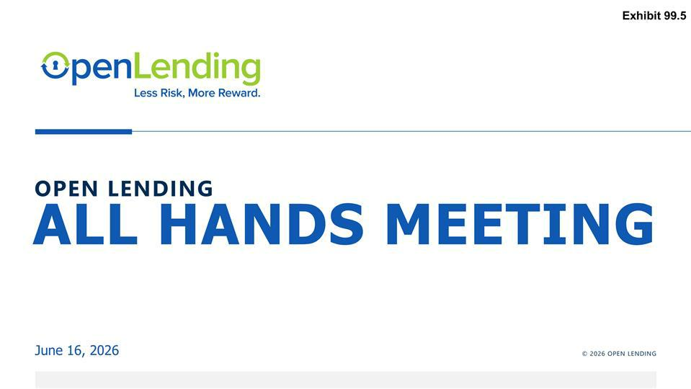

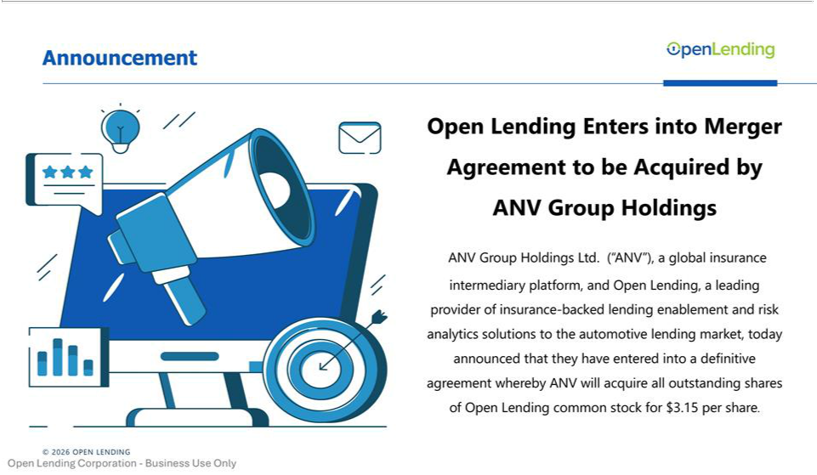

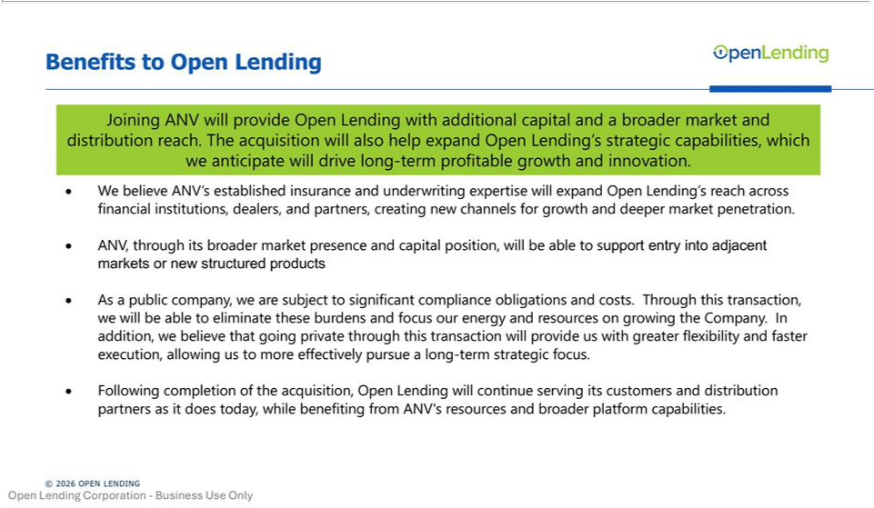

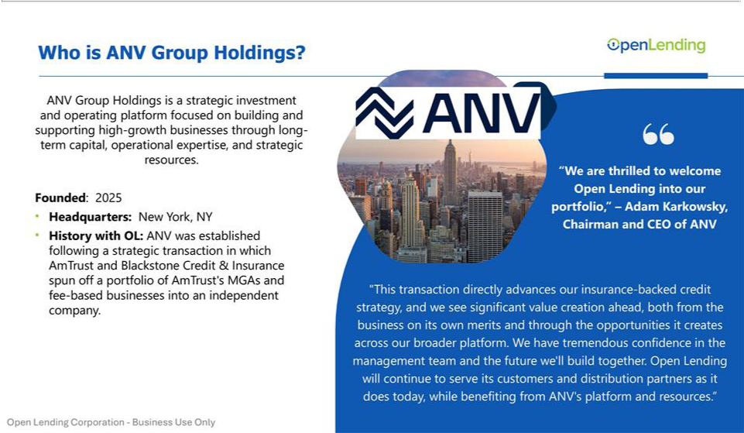

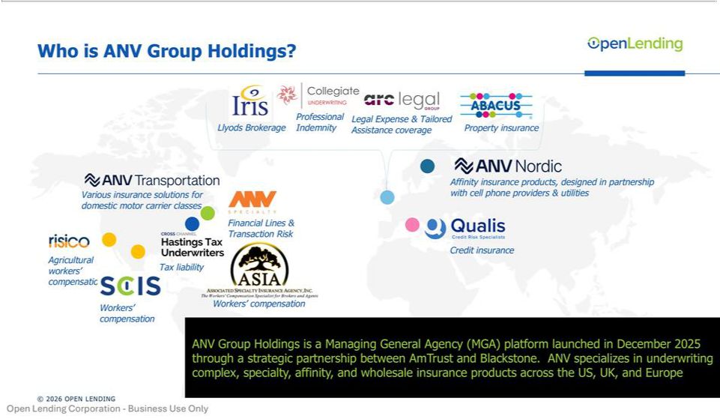

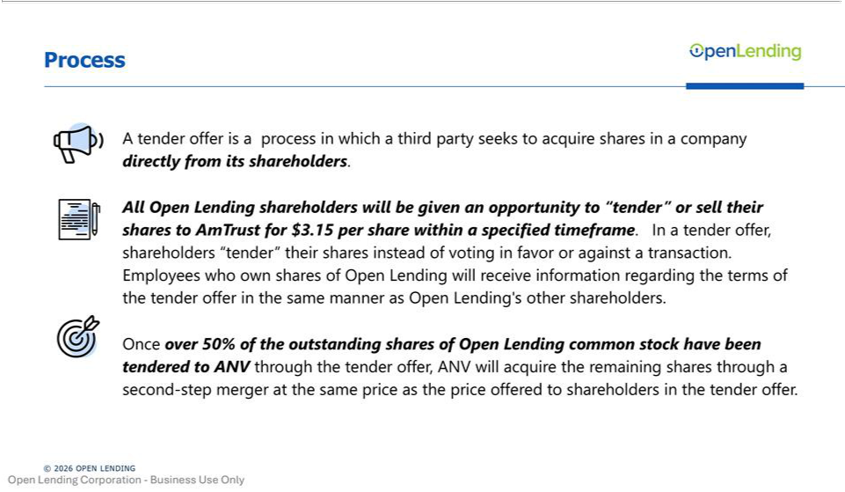

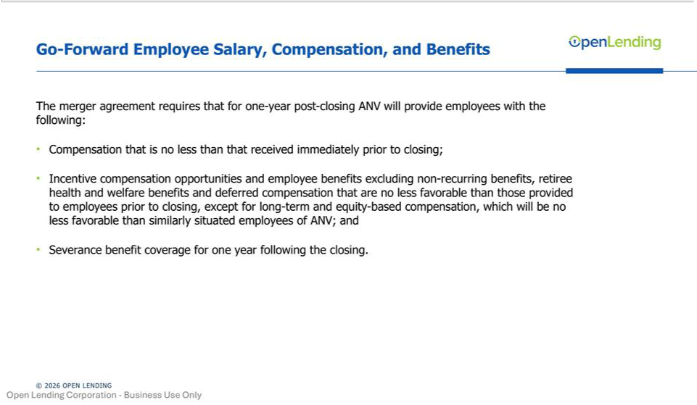

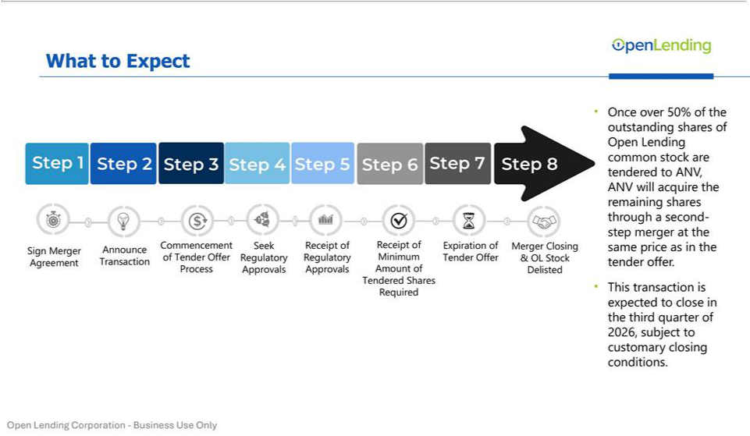

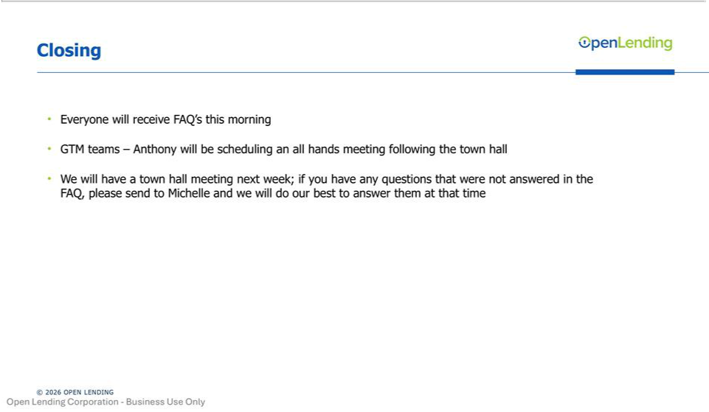

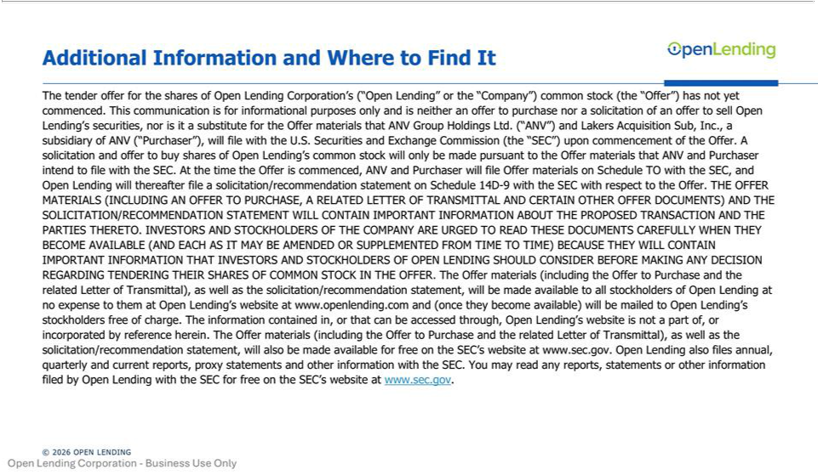

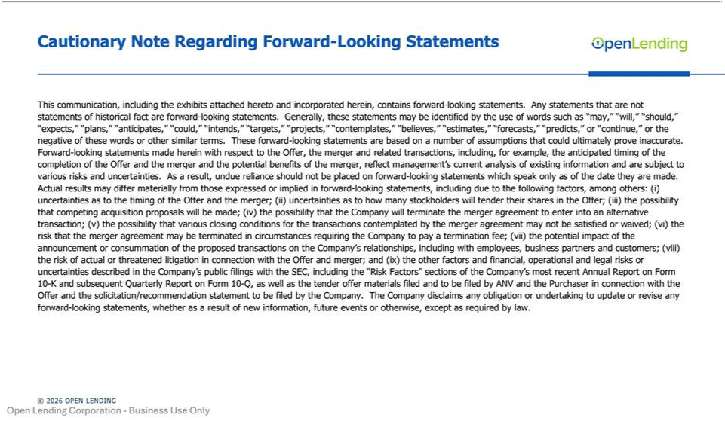

Exhibit 99.6

Open Lending Account

We’re thrilled to announce that Open Lending has entered into a definitive agreement to be acquired by ANV Group Holdings Ltd. This is a milestone moment for our company, our customers, and our team.

For more than two decades, Open Lending has helped financial institutions expand access to automotive credit through proprietary risk decisioning technology and insurance-backed credit solutions. Joining forces with ANV gives us the capital, strategic capabilities, and platform to go even further — accelerating innovation, expanding our reach, and driving long-term growth.

To our associates: this reflects everything you’ve built. Your hard work, your dedication, and the meaningful impact you make every day made this possible.

To our customers and partners: our commitment to you is stronger than ever. Open Lending will continue to serve its customers and distribution partners as it does today, while benefiting from ANV’s platform and resources.

The best is ahead. We can’t wait.

Additional information may be found at: https://lnkd.in/gMhHCtrx

Jessica’s Account

Today is an exciting milestone for Open Lending.

We’ve entered into a definitive agreement to be acquired by ANV Group Holdings.

This step reflects the strength of our platform, the trust our customers place in us, and the dedication of our team. We are entering this next chapter from a position of momentum, and I’m confident it further strengthens Open Lending’s foundation for continued growth and innovation.

Open Lending will continue serving its customers and distribution partners as it does today, while benefiting from ANV’s resources and broader platform capabilities.

I’m incredibly proud of what our team has built and grateful to our customers and partners for the trust they place in us every day.

Additional information may be found at: https://lnkd.in/dTHZurJM

Additional Information and Where to Find It

The tender offer for the shares of Open Lending Corporation’s (“Open Lending” or the “Company”) common stock (the “Offer”) has not yet commenced. This communication is for informational purposes only and is neither an offer to purchase nor a solicitation of an offer to sell Open Lending’s securities, nor is it a substitute for the Offer materials that ANV Group Holdings Ltd. (“ANV”) and Lakers Acquisition Sub, Inc., a subsidiary of ANV (“Purchaser”), will file with the U.S. Securities and Exchange Commission (the “SEC”) upon commencement of the Offer. A solicitation and offer to buy shares of Open Lending’s common stock will only be made pursuant to the Offer materials that ANV and Purchaser intend to file with the SEC. At the time the Offer is commenced, ANV and Purchaser will file Offer materials on Schedule TO with the SEC, and Open Lending will thereafter file a solicitation/recommendation statement on Schedule 14D-9 with the SEC with respect to the Offer. THE OFFER MATERIALS (INCLUDING AN OFFER TO PURCHASE, A RELATED LETTER OF TRANSMITTAL AND CERTAIN OTHER OFFER DOCUMENTS) AND THE SOLICITATION/RECOMMENDATION STATEMENT WILL CONTAIN IMPORTANT INFORMATION ABOUT THE PROPOSED TRANSACTION AND THE PARTIES THERETO. INVESTORS AND STOCKHOLDERS OF THE COMPANY ARE URGED TO READ THESE DOCUMENTS CAREFULLY WHEN THEY BECOME AVAILABLE (AND EACH AS IT MAY BE AMENDED OR SUPPLEMENTED FROM TIME TO TIME) BECAUSE THEY WILL CONTAIN IMPORTANT INFORMATION THAT INVESTORS AND STOCKHOLDERS OF OPEN LENDING SHOULD CONSIDER BEFORE MAKING ANY DECISION REGARDING TENDERING THEIR SHARES OF COMMON STOCK IN THE OFFER. The Offer materials (including the Offer to Purchase and the related Letter of Transmittal), as well as the solicitation/recommendation statement, will be made available to all stockholders of Open Lending at no expense to them at Open Lending’s website at www.openlending.com and (once they become available) will be mailed to Open Lending’s stockholders free of charge. The information contained in, or that can be accessed through, Open Lending’s website is not a part of, or incorporated by reference herein. The Offer materials (including the Offer to Purchase and the related Letter of Transmittal), as well as the solicitation/recommendation statement, will also be made available for free on the SEC’s website at www.sec.gov. Open Lending also files annual, quarterly and current reports, proxy statements and other information with the SEC. You may read any reports, statements or other information filed by Open Lending with the SEC for free on the SEC’s website at www.sec.gov.

Cautionary Note Regarding Forward-Looking Statements

This communication contains forward-looking statements. Any statements that are not statements of historical fact are forward-looking statements. Generally, these statements may be identified by the use of words such as “may,” “will,” “should,” “expects,” “plans,” “anticipates,” “could,” “intends,” “targets,” “projects,” “contemplates,” “believes,” “estimates,” “forecasts,” “predicts,” or “continue,” or the negative of these words or other similar terms. These forward-looking statements are based on a number of assumptions that could ultimately prove inaccurate. Forward-looking statements made herein with respect to the Offer, the merger and related transactions, including, for example, the anticipated timing of the completion of the Offer and the merger and the potential benefits of the merger, reflect management’s current analysis of existing information and are subject to various risks and uncertainties. As a result, undue reliance should not be placed on forward-looking statements which speak only as of the date they are made. Actual results may differ materially from those expressed or implied in forward-looking statements, including due to the following factors, among others: (i) uncertainties as to the timing of the Offer and the merger; (ii) uncertainties as to how many stockholders will tender their shares in the Offer; (iii) the possibility that competing acquisition proposals will be made; (iv) the possibility that the Company will terminate the merger agreement to enter into an alternative transaction; (v) the possibility that various closing conditions for the transactions contemplated by the merger agreement may not be satisfied or waived; (vi) the risk that the merger agreement may be terminated in circumstances requiring the Company to pay a termination fee; (vii) the potential impact of the announcement or consummation of the proposed transactions on the Company’s relationships, including with employees, business partners and customers; (viii) the risk of actual or threatened litigation in connection with the Offer and merger; and (ix) the other factors and financial, operational and legal risks or uncertainties described in the Company’s public filings with the SEC, including the “Risk Factors” sections of the Company’s most recent Annual Report on Form 10-K and subsequent Quarterly Report on Form 10-Q, as well as the tender offer materials filed and

to be filed by ANV and the Purchaser in connection with the Offer and the solicitation/recommendation statement to be filed by the Company. The Company disclaims any obligation or undertaking to update or revise any forward-looking statements, whether as a result of new information, future events or otherwise, except as required by law.

